COVID-19 Workspace Safety Plan.

This plan requires the review of the operational activities in your workspace to ensure effective controls are in place to prevent the transmission of COVID-19. Management and supervisory staff are responsible for developing and updating this document to meet current government mandated requirements. https://covid19.ubc.ca/

Department | UBC Centre for Sustainable Food Systems at UBC Farm
Faculty | Land and Food Systems
Facility Location | UBC Farm
Workspace Location | Outdoor grounds – Event and  Film Rental Space

Introduction to Your Operation

For the purpose of this application, we are only presenting the opening of the outdoor grounds area to include the venue spaces Events Field, Orchard and Poplar Grove. The buildings and indoor spaces of UBC Farm including office and classroom space, have separate operating plans, which have been approved previously.

UBC Farm is a unique outdoor event venue managed by the UBC Farm. The footprint of the event space is limited to the outdoor venue areas. The rental of the facility is primarily for weddings, small meetings, social and academic functions, guided tours, along with commercial filming.

At this time, and until the BC Provincial Health Officer and BC’s Restart Plan is adjusted to allow gatherings of over 50 people, UBC Farm will be booking Micro Weddings, workshop events, social events, for up to 50 guests, depending on additional staff needed for the event. Guided tours will have a maximum of 15 guests. Commercial film booking will resume, with a maximum of 50 crew members on-site; productions must have a fully developed and approved COVID-19 WorkSafeBC Safety Plan. All of these events will have specific floor plans and social distancing measures tailored to fit their individual needs. These floor plans and event plans will be reviewed by the UBC Farm Site and Events team and approved by the UBC Farm Operations Director.

High-level operational activities include writing contracts, designing and setting up floor plans, approving third party vendors, scheduling security and coordinating all event details with UBC Scholar’s Catering and UBC Building Operations.

Section #1 – Regulatory Context
List any other relevant guidance documents or resources used for your workspace plan. This may include:
1. Federal Guidance

COVID-19 Safety Plan Template

2. Provincial and Sector-Specific Guidance
- Order of the Provincial Health Officer – Mass Gathering Events https://www2.gov.bc.ca/assets/gov/health/about-bc-s-health-care-system/office-of-the-provincial-health- officer/reports-publications/covid-19-pho-class-order-mass-gatherings.pdf

  - A person who is the owner, occupier or operator of, or is otherwise responsible for, an indoor or outdoor place hosting an event, other than a drive-in event, must not permit the gathering of more than 50 patrons for the purpose of the event.

- BC’s Restart Plan https://www2.gov.bc.ca/gov/content/safety/emergency-preparedness-response- recovery/covid-19-provincial-support/bc-restart-plan
  - Currently events hosting 50 guests or higher is set for Phase 4 of the restart plan.

- British Columbia – Key Steps to Safely Operating Your Business or Organization and Reducing COVID-19 Transmission. https://www2.gov.bc.ca/assets/gov/public-safety-and-emergency-services/emergency- preparedness-response-recovery/gdx/go_forward_strategy_checklist_web.pdf
  - Core measures set out by BC Government to review and plan for any business and institutional resumption plan.
- http://www.bccdc.ca/Health-Professionals-Site/Documents/Face-masks.pdf
  - We plan to follow UBC guidelines on masks, but will supply this information to our alumniUBC facility team as well, to allow each staff member to make the informed decision on how to wear masks if they choose to.

- B.C. Motion Picture Industry COVID-19 Safety Guidelines
  - Guidelines for filming will be additionally supplied by UBC Campus and Community Planning’s Film and Events office.
3. WorkSafeBC Guidance
- Preventing exposure to COVID-19 in the workplace: A guide for employers https://www.worksafebc.com/en/resources/about-us/guides/preventing-exposure-to-covid-19-in-the- workplace?lang=en
  - Orders from the provincial health officer (PHO) and guidance to employers and businesses provided by the BC Centre of Disease Control. Must be reviewed and implemented as alumniUBC facility staff do not fall under UBC staffing umbrella. This is a great resource to cross check all vendor COVID-19 safety planning.
- Selecting and using masks
https://www.go2hr.ca/resource-library/covid-19-health-and-safety-selecting-and-using-masks
  - We plan to follow UBC guidelines on masks, but will supply this information to our alumniUBC facility team as well, to allow each staff member to make the informed decision on how to wear masks if they choose to.
- Entry check for visitor signage
https://www.worksafebc.com/en/resources/health-safety/posters/help-prevent-spread-covid-19-entry- check-visitors?lang=en
- WorkSafeBC Motion picture and television productions: Protocols for returning to operation https://www.worksafebc.com/en/about-us/covid-19-updates/covid-19-returning-safe-operation/motion-
picture-television-production
Every production must have their own workSafeBC safety plan, they must provide this plan to CGPH manager
and UBC Film and Outdoor Event Manager
4. UBC Guidelines
- UBC Safety and Risk Services PPE Guidance
https://riskmanagement.sites.olt.ubc.ca/files/2020/04/COVID-19-PPE-Guidance_final.pdf

- UBC Safety and Risk Services Resources
https://srs.ubc.ca/covid-19/communications-resources/

- COVID Health and Safety Page
https://srs.ubc.ca/covid-19/health-safety-covid-19/

- UBC Safety and Risk Services, preventing exposer to COVID-19 landing page
https://srs.ubc.ca/covid-19/health-safety-covid-19/prevention/

- Risk Assessment & Safe Work Procedure (SWP) landing page
https://srs.ubc.ca/health-safety/safety-programs/risk-assessment-safe-work- procedure/

- Risk Assessment & Safety Reporting Covid-19 Exposure https://srs.ubc.ca/covid-19/health-safety-covid-19/reporting-covid-19-exposure/

- UBC Covid-19 resource page https://covid19.ubc.ca/resources/

- UBC Employees COVID-19 Use of Shared UBC Vehicles Guidance [PDF]

- UBC Cleaning Standards & Recommendations for Supplementary Cleaning [PDF]

5> Professional/Industry Associations
1) Go2HR BC’s tourism human resources association
- https://www.go2hr.ca/health-safety/resources/covid-19-resources

Section #2 - Risk Assessment
As an employer, UBC has been working diligently to follow the guidance of federal and provincial authorities in implementing risk mitigation measures to keep the risk of exposure as low as reasonably achievable. This is most evident in the essential service areas that have remained open on campus to support the institution through these unprecedented times. These areas have been very active with respect to identifying and mitigating risks, and further re-evaluating the controls in place using the following risk assessment process.

Prior to opening or increasing staff levels:
Where your organization belongs to a sector that is permitted to open, but specific guidance is lacking as to what activities under that sector are lacking, you can use the following risk assessment approach to determine activity level risk by identifying both your organization’s or activity’s contact intensity and contact number, as defined below:

- What is the contact intensity in your setting – the type of contact (close/distant) and duration of contact (brief/prolonged)?

We have broken this down into type of event and staffing departments as the guest count and steps to manage or control distancing can vary.

Note: Resumption of activity may need to be reversed or adjusted, and additions may be imposed in response to public health guidance or changes to the situation on our campuses

  - Office and on-site staff: The UBC Centre for Sustainable Food Systems at UBC Farm (UBC Farm) operates the rental of several designated, outdoor grounds of UBC Farm, including the Events Field, Orchard, and Poplar Grove spaces – the team that manages these venues are noted as the Site team, they are comprised of the Site Coordinator, Operations Director, Field Manager, and Community Events Assistant.

The current plan is to use the existing Site team staff members for on-site support and supervision of events. If this were to be adjusted, an amended proposal would be submitted to this committee for review.

    - The Site team will continue to work from their home offices on a day to day basis.
    - At the time of any booked event, one or multiple members of the facility team will be on-site. They are to provide the following support:
- Ensure floor plan is set based off approved floor plans.
- Ensure that any event security has arrived and is in place.
- Be on-site with event phone to assist with any client or vendor questions, and general supervision (to be done at a distance).
    - During any event or meeting the Site team member will be located adjacent to the event site, in an outdoor area that is physically removed from the event floor plan.
    - If a UBC Farm Site team member has a concern about returning to work, they will have an opportunity to discuss that with their supervisor, Human Resources, and their employee group as appropriate.
    - If anyone; UBC Farm employee, UBC supporting staff such as custodial or BOP member, or third-party vendor, is arriving to campus to work on-site at UBC Farm and is unwell or exhibits any COVID-19 symptoms, they must not return to the workplace and must inform their supervisor.
    - Risks should be reduced equally for all individuals, and not vary by position or rank.
    - Considerations will need to be made for adjusting schedules for those with special circumstances, including childcare or eldercare responsibilities, or for those more vulnerable to COVID-19 due to medical conditions.

UBC Site Team and Building Operations (BOPS)

    - The Site Team will be required to oversee the set up and tear down all floor plans. This work will be planned for when there are no other staff members on working within the floor plan area.
    - Pre and post event cleaning will be provided by the Site Team or from UBC BOPS. The frequency of cleaning will remain intact from pre COVID-19, with additional standards of sanitation according to COVID-19 specific guidelines. Additional sanitation key touch points will be requested.
A two to three-hour window will be scheduled between every event to allow time to ensure cleaning and sanitizing is safely completed for any items shared between events.

Micro Weddings and Social Events (celebrations of life, birthdays, etc.)

    - All special event rentals will be promoting outdoor events; utilizing the grounds for outdoor ceremony and picnic style small receptions.
    - Rentals are billed out on an hourly basis; this is to accommodate and encourage shorter bookings, e.g.: One hour “elopement” wedding ceremony.
    - Social event hours are billed out hourly this includes load in or load out times.
    - All external events will have a set end time of 5:00PM, down from our previous end time of 9:00PM.
    - All internal events (hosted by the UBC Farm, Faculty of Land and Food Systems, or our partners) will have a set end time of 9:00PM.
    - Guests arriving to any wedding or private event will have a preset and agreed upon floor plan or outdoor seating arrangement. This seating arrangement will be grouped together by identified households. Only people who live within the same household can be seated together. All other guests will need to be placed at a minimum of 2 meters apart.
    - A seating plan will be sent to guests prior to the event, and signage indicating placement will be on-site.
    - Clients will be asked to review, sign and commit to the guidelines set out in the UBC Farm COVID-19 Booking Client Commitment Document. See Appendix A.
    - Clients will be asked to share a copy of the UBC Farm COVID-19 Guest Agreement to all staff, guests and vendors who will be on-site for their booking. See Appendix B.
    - Signage will be visible and in place throughout the venue area (note they may be moved around to fit the specific areas used per each individual event). This signage will address social distancing, handwashing, WorkSafeBC workplace entrance expectations, and general COVID-19 health and safety measures. See Appendix C.
    - All venue entrance and exit areas will be designated for either single entrance or exit use. These areas must remain available for all usage to accommodate accessibility. Sample floor plan provided in Appendix D.

    - Access routes leading to event washrooms will be set up to go one-way. An area for guests to queue for washroom access will be created, and indicated with signage. Floor plan indicating this setup located in Appendix D. Washrooms will be temporary units with occupancy of one person at a time.
    - Sample seating plans can be found in Appendix E. Note that each seating plan would be tailored to the individual event.
    - All vendors, including Scholars Catering, will provide drop off and pick up time slots; whenever possible time slots will offer single vendor access to the venue area. When not possible, a plan will be in place to allow for safe social distancing set up and tear down of event equipment to occur.
    - Up to two security guards will be hired to ensure that event does not exceed confirmed guest count, and that booking times and curfew are adhered to.
    - Weddings will not include dancing.

Meetings, including but not limited to arbitration, leadership retreats, and small UBC and community meetings.

    - Rental offerings will promote outdoor meetings.
    - A pre-set and agreed upon floor plan or outdoor seating arrangement must be approved by the Site Coordinator and Operations Director of UBC Farm no later than 5 business days prior to event booking.
    - Floor plan must allow for minimum 2 meter spacing between each individual.
    - Access routes leading to event washrooms will be set up to go one-way. An area for guests to queue for washroom access will be created, and indicated with signage. Floor plan indicating this setup located in Appendix D. Washrooms will be temporary units with occupancy of one person at a time.
    - All vendors including Scholars Catering will provide drop off and pick up time slots, whenever possible time slots will offer single vendor access to the venue areas. When not possible, a plan will be in place to allow for safe social distancing set up and tear down of event equipment to occur.
    - Clients will be asked to email a copy of the UBC Farm COVID-19 Guest Agreement to all staff, guests and vendors who will be on-site for their booking. See Appendix B.

Tours, including guided tours for UBC staff, students and faculty, and tours for external guests and community groups.

    - Tours will be offered in groups of 15 guests, plus one tour guide.
    - Participants will be encouraged to wear masks during the tour duration.
    - The tour guide will make use of a portable voice amplifier, to be used while wearing a mask or face covering.
    - The portable voice amplifier will be sanitized with alcohol spray before returning to the UBC Farm site office post-tour.
    - An appropriate mask must have two layers of tightly woven fabric (cotton or linen), or be a commercially produced disposable non-medical mask, and securely fit, without gaping, over the nose and mouth with ties or ear loops. Masks will be available to UBC Farm tour guides if needed.
    - Tours will be offered during set time slots per week, unless otherwise requested. The Site Coordinator will ensure that any tour request times will not overlap with other public events at the Farm, including Farmers’ Markets, private events, and public workshops.
      - Proposed time slots are Tuesdays: 3:00 – 4:00PM, Saturdays: 2:30 – 3:30PM
    - Tours will be required to agree to and sign our Guided Tour Guest Agreement, which can be found in Appendix L.

Filming, to be planned and managed in partnership with UBC outdoor film and event office. Full filming plan can be found in Appendix F.

Staffing Requirements

1. What is the number of contacts in your setting – the number of people present in the setting at the same time?

We have broken this down into departments and type of event as the guest count and steps to manage or control distancing can vary.

- UBC Farm will have one or more Site staff member on-site for booked meetings and events. Our expectation is that we will have one to two bookings per week. The majority of their work will continue at the team member’s home office.

- Renters/Vendors/Site Team will be required to provide set up, take down, and pre and post-event cleaning. We will be working closely with renters to ensure that they are aware of all events and floor plans well ahead of time so consultation and any safety planning can be facilitated.

- Micro Weddings, Elopements and Social Events will have a maximum capacity of 50 guests at any event, including staff, vendors and others present for the event. Prior to the event an approved outdoor plan and rain plan must be reviewed and approved the UBC Farm Site Coordinator and Operations Director. Whenever possible these plans will be created by the UBC Farm Site Coordinator in consultation with each client, event planner and partnered vendors, if applicable. In order to approve or create floor plans for clients, facility staff must receive the following:
- List of all confirmed guests grouped by household.
- List of all vendors who will require pre/post access to the venue areas.
- List of all vendors that will require access to the venue areas while guests are in attendance – or during any time during the event.
- A draft floor plan to be reviewed and approved by UBC Farm Site Coordinator (minimum four days prior to event)

- Tours must have no more than 15 guests per group, and must follow physical distancing regulations. Each tour group must complete a registration form online, including information of each attending guest for contact tracing. See Tour Plan Appendix
- Filming must follow provincial rules and have no more than 50 crew members on set. See film plan Appendix F.
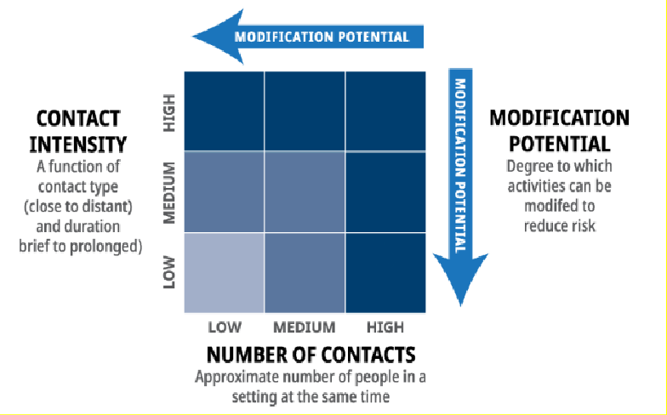

One or more steps under the following controls can be taken to further reduce the risk, including:
- Physical distancing measures – measures to reduce the density of people
  - Controlled and reduced capacity measures will be in place with pre-determined floor plans.
- Engineering controls – physical barriers (e.g.: Plexiglas or stanchions to delineate space) or increased ventilation
  - All entrances and exits are routed to single access points.
  - Floor decals, signage and stanchions will be in place to create one-way traffic through doorways, access to washrooms and walkways throughout the venue areas.
  - Controlled physical distancing through preset floor plans.
  - Events are focused on the outdoor grounds or in rented tents. All of our indoor venue spaces are closed.
  - If an event is taking place in a rented tent, physical distancing and other controls should be used, as well as using wall less tents or windows to maintain ample airflow. (Note: Walled tents are considered indoor spaces, and UBC’s non-medical mask guidelines, as well as fire code standards, will need to be applied.)

- Administrative controls – clear rules and guidelines
  - Mandatory event end time of 5:00PM for external rentals
  - Mandatory event end time of 9:00PM for internal events.
    - Clients will be asked to email a copy of the UBC Farm COVID-19 Guest Agreement to all staff, guests and vendors who will be on-site for their booking. See Appendix B.
    - Each client is also expected to send us a signed UBC Farm COVID-19 Booking Client Commitment Document. See Appendix A.

- Personal Protective Equipment (PPE) – e.g.: the use of respiratory protection

  - All faculty and staff working on campus will be provided with non-medical masks by their portfolio/Faculty.
  - Medical gloves will be provided, for the single purpose of setting up and taking down special equipment, including in bathrooms.

6. Contact Density (proposed COVID-19 Operations)
Describe the type of contact (close/distant) and duration of the contact (brief/prolonged) under normal operations - where people congregate; what job tasks require close proximity; what surfaces
are touched often; what tools, machinery, and equipment do people come into contact during work.
Renters/Vendors/Site Team will be required to provide set up, take down, and pre and post-event cleaning. We will be working closely with renters to ensure that they are aware of all events and floor plans well ahead of time so consultation and any safety planning can be facilitated. This work would be done when no one else is working in the venue area. Depending on size of event, we would reserve 2 to 3 hours for set up and clean and 2 to 3 hours for tear down and clean.

Items that would need to be cleaned/sanitized include:
- Tables/chairs/ event furniture per floor plan, that belong to the UBC Farm
- All door handles, washrooms and hand washing areas, that belong to UBC Farm
- All equipment owned by the UBC Farm (lighting, hand trucks, equipment)
- All cleaning materials, spray bottles, etc., will need to be restocked pre and post usage.

Any catering providers will be asked to set up an outdoor kitchen area to work from. Food will be set up on tables outside or at individual tables inside based off floor plans. Limited access to our water and power hook-ups, only following groups allowed:
- UBC Farm Site team, Scholar’s Catering, event planners and vendors who require access to water or power.

Outdoor Grounds would be the sole area for weddings and external social events. Maximum time of eight hours per event (9:00AM – 5:00PM). All guests to be grouped by household, and two meters social distance space required between individuals who are not in households.
- Access to the venue areas will be marked to create one way flows of traffic through the venue.
- Washroom access will be clearly defined, see Appendix D.

Vendors who are on-site would be most likely be, but are not limited to; wedding officiants, musicians, DJs, photographers, videographers and event planners. All vendors would be accounted for in maximum guest count if they are required to be in the venue area.
- All vendors would be required to remain two meters away from all guests and be placed, when possible, in a pre-approved area.
- All vendors would be required to share their WorkSafeBC and/or UBC Safety and Risk Services COVID-19 planning documents at minimum 3 business days prior to arriving on-site.

UBC Farm owned equipment (ie. Tables) – Rented items would be pre-set to floor plan and wiped down with disinfectant pre/post usage.

Washrooms – Each event would be required to bring a temporary washroom unit for their guests. No washroom spaces shared by staff will be accessible to any guests or vendors.
If rented units are shared between distinct events, a full servicing would be required between each event, by the company the unit was rented from.

COVID-19 Safety Plan Template

Filming – Please refer to filming plan appendix F.
us – Please refer to Tour agreement Appendix L.
7. Contact Number (proposed COVID-19 Operations) Describe the number of contacts in your proposed COVID-19 operational setting (# of people present in setting at same time)
Wedding and social events - Maximum 50 guests including any third-party vendors that would need be on-site. The final count during the event cannot exceed 50 at any point in time, including attending UBC Farm Site team staff.
- All event schedules will include (whenever possible) individual time slots for vendors to have access to set up/ tear down at separate times.

In non COVID-19 operations the average wedding occupancy ranged for 120 – 300 guests – not including catering staff and vendors. Average meeting occupancy ranged from 20 – 100 guests – with an additional 5-10 vendor staff.

Tours – Maximum 15 guests per guided tour. Tour duration remains 1 hour per group. Maximum two tour groups on site per booking slot. Tours will be given set booking times weekly, unless arranged with the Site Coordinator, which do not overlap with other public activity at the Farm (IE. Farmers markets) Tour guides will be members of the UBC Farm staff Site team (Site Coordinator, Operations Director, Events Assistant). Guests and tour guides will use their discretion to wear masks during the tours. Tour guides will use a portable voice amplifier, to reduce voice projection, and sanitize this equipment immediately after use. See Appendix L.
8. Hazard Identification
Describe what COVID-19-specific hazards exist in your workplace.
Community transmission between guests and/or vendors and staff. However, the precautions described throughout this document will work to minimize this hazard.
9. Employee Input/Involvement
Detail how you have met the MANDATORY requirement to involve frontline workers, Joint Occupational Health and Safety Committees, and Supervisors in identifying risks and protocols as part of this plan
This COVID-19 Workspace Safety Plan was created in consultation with the full UBC Farm Site team, and primarily driven by the Site Coordinator and Operations Director. The primary front-line staff from the UBC Farm Site team will be the Site Coordinator, Community Events Assistant and Operations Director.
Note: The current plan is to use the existing Site team staff members for on-site support and supervision of events. If this were to be adjusted, an amended proposal would be submitted to this committee for review.

- Health and Safety Teams– This team is comprised of a staff member from each department along with the UBC Farm Operations Director. We consulted with the Field Manager and Site Coordinator, who are members of the Joint Occupational Health and Safety Team – Land and Food Systems, and will share with the full LST and JOHSC members. Note that the other programs at the UBC Farm have submitted separate COVID-19 Workspace Safety Plan specific to the spaces that they will be occupying and managing. These plans have all been approved, and will work in tandem with the Events Plan.

- Management Team – This team is comprised of management level staff at the Centre for Sustainable Food Systems at UBC Farm, and are responsible for oversight of UBC Farm programming.

- The Filming Plan was created in partnership with the Film and Events Manager for UBC for Cecil Green Park House. This plan has been adapted for the UBC Farm site.

COVID-19 Safety Plan Template

- UBC Scholar’s Catering, will be submitting a separate plan to cover any catering service for the facility. Our departments will be sharing our plans and will be working in close consultation for any meetings or events held onsite.

Overall our onsite front-line staff training, identified risks and protocols are comprised of:

- One UBC Farm Site team member will be required to be on-site for all meetings and events. They will be present during the load in and initial greeting of vendors. This staff member will not need to remain on the event floor for the duration of the event. A temporary mobile work station will be set-up adjacent to the venue area, allowing visual access to the venue areas.
The mandatory requirements that are being met for this UBC Farm facility member are as follows: Training on all safe working procedures, current COVID-19 process, heath and safety guidance. To include:
- Review of all social distancing measures, floor and directional plans for the venue areas. This will be done virtually and not include physical documentation and training materials
- The facility employees’ will follow UBC policy regarding non-medical masks.
- Facility will provide non-medical masks for facility staff and vendors to use if required as per UBC policy.
- Hand sanitizer and disinfectant wipes will be supplied to employees work stations.
- Training to review handwashing procedures.
- If any UBC Farm, UBC, or vendor staff are unwell and exhibit any COVID-19 symptoms, they must not come to campus or the UBC Farm event site – they must inform their supervisor, event planner and/or venue manager. No exceptions can be made.

BOP/Proctor/Custodial & UBC vendor departments

Our expectation is that building operations (custodial), and Scholar’s Catering will also be reviewing and adjusting the SWP for the specific work at UBC Farm.
0. Risk Level Determination (H/M/L)
Identify the COVID-19 risk category (High / Medium / Low) pre-mitigations for your operation using the BC COVID-19 Go Forward Management Strategy Risk Matrix
Risk Level is Medium to Low
The facility falls in Phase 2 and 3 of the BC Restart Plan.

In this plan we have assessed the risk and included pre-mitigations for our operation to include the following:

- Where do people congregate; all floor plans will be pre-planned and communicated to allow for social distancing and proper spacing.
- Job and tasks have been defined; most of the work will continue on an at-home basis. When a Site team member is on-site they will be able to work at a social distance.
- Tools have been identified; the only medium to high risk task will be setting up and taking down AV or washroom equipment – PPE will be provided to do this safely (gloves). All other equipment and tools will be brought on site by the renter, and will not be used between events unless pre-planned and sanitized.

COVID-19 Safety Plan Template

- All shared surfaces will be cleaned; clearly outlined communication and scheduling with the Site team and BOPS will help facilitate this.
- We have reduced capacities and booking times to decrease risks.
- Clear policies and communication tools have been created for clients and staff.
11. Worker Health
Detail how all Supervisors have been notified on appropriate Workplace Health measures and support available and how they will communicate these to employees
The primary front-line staff from the UBC Farm Site team will be the Site Coordinator and Community Events Assistant. Note: The current plan is to use the existing Site team staff members for on-site support and supervision of events. If this were to be adjusted, an amended proposal would be submitted to this committee for review.

Once this plan has been approved a virtual team meeting will be held to review the plan in detail. Along with this a thorough review and planning session will be in place for each individual event as they come up. This will occur weekly.

Supervisor will conduct one to one conversations with each employee.
If a UBC Farm team member has a concern about returning to work, they will have an opportunity to discuss that with their supervisor, Human Resources, and their employee group as appropriate.

All UBC Farm staff will be provided training and documentation outlining COVID-19 safety protocols based on guidance from WorkSafeBC, the Provincial Health Officer, and UBC. They will also support the mental health and wellbeing of individuals If an employee has a concern about returning to work, they will have an opportunity to discuss that with their supervisor, Human Resources, and/or their employee group as appropriate.
- If any UBC Farm, UBC or third-party vendor employee returning to work on campus is unwell and exhibits any COVID-19 symptoms, they must not return to the workplace and must inform their supervisor.
- Risks should be reduced equally for all individuals, and not vary by position or rank.
- Considerations will need to be made for adjusting schedules for those with special circumstances, including childcare or eldercare responsibilities, or for those more vulnerable to COVID-19 due to medical conditions.
- UBC Farm and UBC employees are permitted to use non-medical masks while at work, and are welcome do so, but should understand the risks and limitations associated with them. They do not substitute for adequate physical distancing.
12. Plan Publication
Describe how you will publish your plan ONLINE and post in HARD COPY at your workplace for employees and for others that may need to attend site
- Plans will be posted on our UBC Farm website – (A new landing page is being created for this purpose & other COVID-19 booking information)
- Digital copies will be in our UBC Farm staff server, and sent to all staff via email. A physical copy will be posted at our UBC Farm office for on site Farm staff.
- Links to this plan will be provided to all third-party vendors and clients.
- Plans will be shared with the UBC Farm staff and community program leaders (Maya Garden, Tu’Wusht, and Indigenous Research Partnerships).

COVID-19 Safety Plan Template

Section #3 – Hazard Elimination or Physical Distancing
Coronavirus is transmitted through contaminated droplets that are spread by coughing or sneezing, or by contact with contaminated hands, surfaces or objects. UBC’s goal is to minimize COVID-19 transmission by following the safety hierarchy of controls in eliminating this risk, as below.

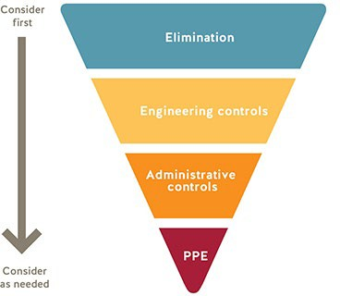

The following general practices shall be applied for all UBC buildings and workspaces:
- Where possible, workers are instructed to work from home.
- Anybody who has travelled internationally, been in contact with a clinically confirmed case of COVID-19 or is experiencing “flu like” symptoms must stay at home.
- All staff are aware that they must maintain a physical distance of at least 2 meters from each other at all times.
- Do not touch your eyes/nose/mouth with unwashed hands.
- When you sneeze or cough, cover your mouth and nose with a disposable tissue or the crease of your elbow, and then wash your hands.
- All staff are aware of proper handwashing and sanitizing procedures for their workspace.
- Supervisors and managers must ensure large events/gatherings (> 50 people in a single space) are avoided.
- Management must ensure that all workers have access to dedicated on-site supervision at all times.
- All staff wearing non-medical masks are aware of the risks and limitations of the face covering they have chosen to wear or have been provided to protect against the transmission of COVID-
19. See SRS website for further information.

13. Work from Home/Remote Work
Detail how/which workers can/will continue to work from home (WFH); this is required where it is feasible

COVID-19 Safety Plan Template

- All day to day “office” work will continue from home. One member of the facility staff will need to be on- site for any booked meetings or events. Our expectation is to have approximately one or two of these booked per week.
- Considerations will need to be made for adjusting schedules for those with special circumstances, including childcare or eldercare responsibilities, or for those more vulnerable to COVID-19 due to medical conditions.
- The event facility operations will not impede the Farm staff’s ability to perform their usual duties, or impede community programs from operating safely. The event venues are restricted to outdoor spaces only. The office and work spaces at the Farm do not share any entrance/exit/washrooms or floor space with the event facility.

14. Work Schedule Changes/Creation of Work Pods or Crews or Cohorts
For those required or wanting to resume work at UBC, detail how you are able to rescheduling of workers (e.g. shifted start/end times) in order to limit contact intensity at any given time at UBC; describe how you may group employees semi-permanently to limit exposure to specialized workers, if applicable
Currently, shifts are only planned to match any booked event time. We will have one person scheduled and then one person always available as a back up shift (this is to allow space in case the person scheduled is unwell).
15. Spatial Analysis: Occupancy limits, floor space, and traffic flows Using UBC building key plans:
- Identify and list the rooms and maximum occupancy for each workspace/area;
- Illustrate a 2 meter radius circle around stationary workspaces and common areas; and
- Illustrate one-way directional traffic flows
This plan covers the re-opening of the event facility and not the offices. We will have one UBC Farm Site team member at a time using a designated work area set up at the time of the event, which is not in a traditional office area as they are on-site for a supervisory role only. This member will have access to UBC Farm staff washrooms. The facility member will need to access a common office for keys and other materials at times – they will be able to access our office only when physical distancing can be maintained.

- The UBC Farm Site Coordinator and Operations Director have a workspace in the UBC Farm Centre Office – Main. They will be considered in the re-opening plans for this office. We will ensure that when a return to work at the offices does occur all safety protocols and workspace occupancy guidelines are met.

COVID-19 Safety Plan Template

Pre-COVID-19 and continuing: The UBC Farm staff working on site do not regularly work in the venue spaces outlined here.

Filming - there can be, at times, a request to access buildings or other work areas. If this is requested when UBC Farm staff are not using the area, we would assess their use of the space and accept if there was minimal contact with surfaces and equipment by crew. If the UBC Farm staff are unable or unamenable to do this, the film crew would have zero access to this area.

Washrooms - There are both portable and indoor washrooms at the UBC Farm, with all being single capacity only. Indoor locations having restricted access to pre-designated staff only, and outdoor washrooms are available to staff, researchers and farmers’ market customers. All staff washrooms will be off limits to event guests.
There will be one designated public washroom for event guests to use, which will be sanitized post-event by Site team staff. All portable units receive a weekly service, including sanitization pressure wash by the company they are rented from.

- Handwashing and social distancing signage will be placed near each washroom. See Appendix C.
- Directional signage on how to access the washrooms, hallways and where to safely line up will be in place. See Appendix D.

Pathways - Access to the event floor will be promoted through a one way flow of traffic outlined in the floor plan. At times, the doorway access or exit directions may change to suit the specialized event floor plan and accessibility needs. The general guidance for all floor plans is to allow either entrance or exit per natural opening (ie. Between orchard rows). See sample floor plans in Appendixes D & E.
16. Accommodations to maintain 2 meter distance
Please detail what accommodations/changes you have made to ensure employees can successfully follow the rule of distancing at least 2 meters from another employee while working
- Pre-approved and pre-set floor plans will be created to match each individual event needs. All household members can be grouped together in a seating unity (pod). Each pod must be at minimum 2 meters apart. See examples in Appendix E.
- Floor plans will include directions for a one way flow of traffic. Traffic flow will be marked with the goal of maintaining open pathways between seating areas, work areas, and other event set up so all guests and staff can maintain a 2 meter distance.
- Social distancing signage to be placed visibly in each venue area. See Appendix C.
- Staff will not be required to be on the event floor except in case of emergencies, and for set up and tear down.
- All vendors and UBC staff are to set up and prep the event in different time slots to allow for appropriate distancing.
17. Transportation
Detail how you are able to (or not) apply UBC's COVID-19 vehicle usage guidelines to the proposed
operational model - if you cannot apply these guidelines, please describe alternative control measures
A UBC Farm vehicle may be used to transport UBC owned equipment only (ie. Tables). One member of the Site team will be permitted to transport in the vehicle at one time. This same Site team member will be required to spray down high touch surfaces (steering wheel, shifter, door handles, keys, mirrors) in the vehicle immediately after use.
18. Worker Screening

Describe how you will screen workers: 1) exhibiting symptoms of the common cold, influenza or gastrointestinal; 2) to ensure self-isolation if returning to Canada from international travel; and 3) to ensure self-isolation if clinical or confirmed COVID-19 case in household or as medically advised
Prior to any event or shift, the scheduled staff will complete a self-assessment, using the BC survey tool.
A secondary, back-up or on call site staff member will be staffed for every event. This staff member is required to be in town and able to fill an event shift in the case their colleague is unable to be on-site due to illness or has developed symptoms.

Every worker must report any travel outside of the county along with any close contact with a person who has been tested positive with COVID-19

All vendors, guests and staff will experience the following when entering the event site:

- WorkSafeBC: entry check for workspace Signage will be on display in our kitchen, loading bay and office.
- Additional signage to be on display in kitchen, loading bay and office. See Appendix C
- WorkSafeBC: Entry check-in to workspace will be on display at our front door as well as on sandwich board signage at both access points to the grounds, See Appendix C.
19. Prohibited Worker Tracking
Describe how you will track and communicate with workers who meet categories above for worker screenings
We will have one to two UBC Farm Site staff member on-site for the event. They will be scheduled and noted on each event plan. Included in these plans will also be the name and contact of each vendor and client.
- Anyone (vendor, client, guests, UBC Farm or UBC staff member) who is on-site and is reporting or has visible signs of fever, chills, new or worsening cough, shortness of breath, new muscle aches or headache, sore throat, have travelled outside Canada within the last 14 days, or were in close contact with a person who tested positive for COVID-19; will be asked to leave and not enter the Site or venue area.
- Contact name, relationship to the event, phone number, email and address will be retained and reported in post event notes. Tour groups will collective and provide this information also, see appendix L.
- Follow up with clients and vendors may be required.
- Clients will be asked to keep a detailed list of all guests and contact information – to include email, phone number and address.

Section 4 – Engineering Controls
20. Cleaning and Hygiene
Detail your cleaning and hygiene plan, including identification for hand-washing stations and the cleaning regimen required to be completed by departmental staff for common areas/surfaces (BOPS Custodial has limitations on cleaning frequency, etc.).
- Hand washing signage will be placed in all washroom areas. See Appendix C.
- Hand sanitizer will be located at all entrances and high usage areas of the grounds. These will be adjusted to fit each individual event floor plan to suit the footprint of the event and ensure that high usage areas have quick and easy access to these supplies.
- In pre-COVID-19 and current plans, BOPs/Site staff/Custodial provide full cleaning services for all pre and post-event. This will now include all items belonging to UBC Farm, including third party rentals if they are shared between more than one event.

21. Equipment Removal/Sanitation
Detail your appropriate removal of unnecessary tools/equipment/access to areas and/or adequate sanitation for items that must be shared that may elevate risk of transmission, such as coffee makers, kettles, shared dishes and utensils
- All items belonging to UBC Farm, including tables, chairs and AV equipment, will be sanitized between each use.
- Clients must rent and set up any furniture outside of pre-arranged UBC Farm rentals, to be placed on the venue area. UBC and UBC Farm Site staff will not be required to set up or move these items. Note that anything in the venue area will still have to have its placement pre-approved by the
UBC Farm Site Coordinator and Operations Director, via the floor plan – this is to ensure safe social distance measures.
22.Partitions or Plexiglass installation
Describe any inclusion of physical barriers to be used at public-facing or point-of-service areas
- Barriers will not need to be added to the first-floor event space. Specialized floor planning will be in place for each events’ needs, and to ensure safe access and social distancing.
- The alumniUBC facility workstation on the second floor is already located behind a partial wood and glass barrier that allows for full social distancing.

Section 5 – Administrative Controls
23. Communication Strategy for Employees
Describe how your unit has or will communicate the risk of exposure to COVID-19 in the workplace to your employee and the safety controls in place to reduce such risk.
- Dissemination of this Plan to the Land and Food Systems (LFS) JOHSC: Once this plan is complete, it will be distributed to the LFS JOHSC for review. Not only will this give the worker representatives on the committee a chance to preview the document, but it will give them the opportunity to provide further suggestions for improvement.
- Communication of the Plan to UBC Farm Employees, community program members and associates: To communicate the risk of exposure to COVID-19 in the workplace to the employees, the UBC Farm will disseminate this safety plan via e-mail to describe the risks and hazards of COVID-19, and the ways they are mitigated in the hosting of events at the UBC Farm.
- Communication of Worker’s Concerns: When an employee is concerned about any of these policies, they should follow the standard WorkSafeBC reporting guidelines (see Right to Refuse Unsafe Work below). They may also contact their worker representative of the LFS JOHSC to express their concerns. They may also report concerns confidentially to the UBC Farm HR manager (Elena Donskikh) and concerns will be treated discreetly with heads and directors.
- One to two UBC Farm site employees will be required to be on-site, and only during a booked meeting or event.
- All events will be reviewed at a weekly (virtual) UBC Farm Site team meeting. COVID-19 safety, social distancing floor plan, vendor lists, and general event plans and timelines will be discussed in detail. This is an open forum for all Site staff to address concerns and for adjustments to be made.
- If an employee has a concern about returning to work, they will have an opportunity to discuss this with their supervisor, Human Resources, and/or their employee group, as appropriate.
- If anyone (UBC Farm, faculty, staff or students) returning to work on campus is unwell and exhibits any COVID-19 symptoms, they must not return to the workplace and must inform their supervisor.
- Risks should be reduced equally for all individuals, and not vary by position or rank.
- Considerations will need to be made for adjusting schedules for those with special circumstances, including childcare or eldercare responsibilities, or for those more vulnerable to COVID-19 due to medical conditions.
- UBC Farm employees are permitted to use non-medical masks while at work, and are welcome do so; though they should understand the risks and limitations associated with them.
24. Training Strategy for Employees
Detail how you will mandate, track and confirm that all employees successfully complete the Preventing COVID-19 Infection in the Workplace online training; further detail how you will confirm employee orientation to your specific safety plan.

COVID-19 Safety Plan Template

UBC Farm staff are required to log their completion of the UBC Prevention COVID-19 Infection in the Workplace online training by Safety and Risk Services within the LFS Training Resource Management System. This will also be recorded in the Safe Work Procedure document (Appendix K).
- Every event will be reviewed at a weekly virtual team meeting. All entrance, exit and social distancing floor plan strategies will be discussed and planned in detail.
- Each event will have one UBC Farm Site staff member on shift. It will also have one back up team member on call.
- All staff will review how to safely use and remove gloves, as they will be required to use them to set up and dismantle UBC Farm owned rentals. See Appendix G.
- In case of medical emergencies where a guest requires assistance, facility staff are instructed to call 911 and/or inform the guests that they can go to Urgent Care at the UBC Hospital at 211 Wesbrook Mall.
- If a guest has a minor cut, bruising, sprained ankle, pulled muscle, etc., a first aid box will be made available for their use, but facility staff are instructed not to assist and remain at a 2 meter distance.
- All vendors must supply their own WorkSafeBC safety plan to the UBC Farm Site Coordinator no later than three business days prior to arriving on-site.
- All vendors and guests are provided with a Guest Agreement document. See Appendix B
- Filming safety plans are monitored and approved in partnership with the UBC film and event office managed by Arlene Chan. See Appendix F
25. Signage
Detail the type of signage you will utilize and how it will be placed (e.g. floor decals denoting one-way
walkways and doors).
- The UBC Farm will utilize the signage from the Safety & Risk Services COVID-19 website, the Worksafe’s COVID-19 – Resources website, and from Building Operations in addition to its own branded wall and floor signage specific to UBC Farm operations. Required Signage:
  - Signs that state the maximum occupancy of common rooms.
  - Use of signage and flagging tape to block-off areas that are off-limits.
  - Use of signage to direct traffic through high flow areas.
  - Signs to remind people to adhere to physical distancing guidelines.
  - Floor signs to mark of 2 m spaces where people might line up (if needed).
  - Checklist of items that require disinfection at the end of each shift. This should include switches, door handles, keyboards and mice of communal computers, cart handles, etc.
- WorkSafeBC – Entry check in for all visitor signage will be on display at our front door as well as on sandwich board signage at both access points to the SITE. See Appendix C.
- A seating plan will be sent to guests prior to the event and signage indicating placement will be on-site.
- Clients will be asked to email all guests a copy of UBC Farm COVID-19 Guest Agreement. See Appendix B.
- Clients must sign and submit the UBC Farm COVID-19 Booking Client Agreement. See Appendix A.
- Handwashing signage to be placed near each washroom. See Appendix C.
- Signage to be placed at hand sanitizer stations.
26. Emergency Procedures
Recognizing limitations on staffing that may affect execution of emergency procedures, detail your strategy to amend your emergency response plan procedures during COVID-19. Recognizing limitations on staffing that may affect execution of emergency procedures, detail your strategy to amend your emergency response plan procedures during COVID-19. Also describe your approach to handling
potential COVID-19 incidents.
- In cases of medical emergency where a guest requires assistance UBC Farm Site staff are instructed to call 911 and/or inform the guests that they can go to Urgent Care at the UBC Hospital – 211 Wesbrook Mall.
- If a guest has a minor cut, bruising, sprained ankle, pulled muscle, etc., a first aid box will be made available for their use, but facility staff are instructed to not assist and to remain at a 2 meter distance.
- BERP will be reviewed with each facility staff member, copies are visible on our staff drive, staff workspace and in this document. Appendixes H & I.
27. Monitoring/Updating COVID-19 Safety Plan

Describe how you will monitor your workplace and update your plans as needed; detail how employees can raise safety concerns (e.g. via the JOHSC or Supervisor) - plan must remain valid and updated for next 12-18 months.
- UBC Farm employees can raise safety concerns with their supervisor, and collectively discuss safety protocols and concerns at weekly staff meetings.
- The current plan has Site staff members provide all on-site supervision. This may need to be adjusted in the fall or as more events book. If additional staff are hired on a part time basis, this safety plan will be updated, shared for approval through UBC Safety and Risk Services committee and re-sent via email to all staff, and posted at the UBC Farm common areas.
- During events, inclusive of setup and tear down, the venue areas will remain inaccessible for staff.
- UBC Farm Site Coordinator or Operations Director may choose to return to the office to work when they feel it’s appropriate and safe to do so on a day-to-day basis. Consultation with the UBC Farm COVID-19 Safety plan will be done, considerations and training documents will be shared, if required.
28. Addressing Risks from Previous Closure
Describe how you will address the following since the closure: staff changes/turnover; worker roles
change; any new necessary training (e.g. new protocols); and training on new equipment.
The UBC Farm Site team has always supported the UBC Farm venue areas, often in partnership with Scholar’s Catering. The Site team hosts a weekly team meeting (that is currently virtual). This meeting reports past events, highlighting any security or safety, along with client feedback and reviews any upcoming events; reviewing safety and staffing plans. This meeting will continue and specifically review the following;
- Personalized event floor plans.
- All signage requirements.
- Vendor and client load in schedule.
- Ensure that all vendors and clients have received and returned a copy of the UBC Farm COVID-19 Guest Agreement. See Appendix B.
- If a vendor is found to be in non-compliance with plans or any other relevant COVID-19 related policies, this may result in a loss of access to UBC Farm for any future event; including in times post- COVID-19.

For the facility member who will be on-site supervising the event we have compiled the following:

- Risk Assessment Template, can be found in Appendix J.
- General Safe Work Procedure Template, can be found in Appendix K.

Section #6 – Personal Protective Equipment (PPE)
29. Personal Protective Equipment
Describe what appropriate PPE you will utilize and how you will/continue to procure the PPE
- Faculty/staff – All faculty and staff working on campus will be provided with non-medical masks by their portfolio/Faculty.
- Graduate Students/Postdoctoral Fellows – All graduate students and postdoctoral fellows working on campus will be provided with non-medical masks by their portfolio/Faculty.
- Students – Students living in residence, or attending in-person classes on campus will be provided with one branded non-medical masks by their Faculty.
- Visitors – Contractors, service providers and other visitors are required to provide their own non-medical masks.
- Medical gloves will be supplied to Site staff; they are asked to use these when setting up and taking down any UBC Farm owned equipment. These gloves are single use only.
- Disinfecting spray will be provided to wipe down equipment and any workspace.
- Hand sanitizer stations will be set up through the venue areas and at all entrance and exit points.
https://srs.ubc.ca/covid-19/health-safety-covid-19/non-medical-masks/

Section #7 - Acknowledgement
As a possible way to document Safety Plan receipt and understanding by your employees, please feel free to use the template language below under your own departmental/faculty letterhead.

I acknowledge that this Safety Plan has been shared with staff both through email and will be made available as a shared document. Staff can either provide a signature or email confirmation that they have received, read and understood the contents of the plan.

Date | July 23rd 2020
Name (Manager or Supervisor) | Clare Cullen
Title | Operations Director

Faculty and Staff Occupying Workspace

Name | Email | Confirmation  of  Understanding
Clare Cullen | clare.cullen@ubc.ca | Y
Jaylin Melnichuk | jaylin.melnichuk@ubc.ca | Y

Appendix
Please attach any maps, pictures, departmental policies or risk assessments applicable UBC Guidance documents, where necessary, and other regulatory requirements referred to in this document.

Appendix A – UBC Farm COVID-19 Booking Client Commitment
Appendix B – UBC Farm COVID-19 Guest Agreement
Appendix C – Signage
Appendix D – Washroom and one-way flow (UBC Farm)
Appendix E – Sample Floor Plans (Ceremony Rain Plan, Reception Rain Plan, Meeting) Appendix F – UBC Farm Filming Plan
Appendix G – Glove Removal Procedure
Appendix H – UBC Farm BERP
Appendix I – UBC Farm – Office Building BERP
Appendix J – General Risk Assessment (UBC Farm) Appendix K – General SWP Template
Appendix L - UBC Farm COVID-19 Guided Tour Guest Agreement

Appendix A

Appendix A: UBC Farm – COVID ‐19 Booking Client Commitment The safety of our clients, guests and staff members is our top priority. High standards of hygiene and cleanliness are in place within the facility, along with physical distancing measures and reduced capacities. As the event organizer and client, we need your extra support and commitment to ensure that we are all doing our part to protect the spread of COVID‐19. To ensure this, you must review, sign and return this document with your booking contract.

Floor Planning and Guest Communication

- A confirmed guest list will be sent to the UBC Farm Site Coordinator as soon as possible, and no later than six days prior to the event. This list shall be grouped by household. You confirm and are completely honest that these guests all live within one household.
- You and/or your planner, in consultation with the UBC Farm Site Coordinator, will create a seating plan that only allows households to sit within a 2‐meter distance of each other. This should be created soon as possible, no later than six days prior to the event. This must include a Plan B (rain plan).
- The seating plan and overall floor plan must be approved by the UBC Farm Site Coordinator. They will provide you with an approved copy that will also indicate entrance and exit points to the site, along with outlined physical distancing and one‐way traffic zones.
- The client, planner or representative will share this seating plan along with the UBC Farm COVID‐19 Guest Agreement document TO ALL GUESTS, prior to their arrival.

Vendors and Planning

- You will share a detailed timeline for your event and include a list of ALL vendors who will be onsite. This must include company name, manager, onsite contact name, phone number email address.
- You will share the UBC Farm – COVID‐19 Guest Agreement with all vendors who will be arriving or working onsite at the UBC Farm.
- You understand that that any vendors who will be onsite during the event shall count towards final guest numbers and capacity restrictions. With social distancing requirements all Plan B (rain plan), or use of venue areas are limited to a maximum of 50 guests.
- You understand that if your event exceeds maximum event capacities of 50 guests, the event will be asked to shut down immediately. Non‐compliance will include calls to the authorities.
- ANY Staff, Guests or Vendors displaying the following symptoms ‐ Fever * Chills * New or worsening cough * Shortness of breath * New muscle ache or headache * Sore throat *‐ will be asked to leave; no exceptions will be made.

The client’s signature on this document denotes the Client’s acceptance of all the terms and conditions set out in this commitment. Client Name (please print)

Signature Date

Appendix B

Appendix B: UBC Farm – COVID‐19 Guest Agreement

The safety of our clients, guests and staff members is our top priority. High standards of hygiene and cleanliness are in place within the facility, along with physical distancing measures and reduced capacities. We need your commitment and support to ensure that we are all doing our part to protect the spread of COVID‐19. Please be prepared to take the following measures when you are participating in any activity at UBC Farm.

- All staff and guests are asked to not enter UBC Farm if they have any of the following symptoms:

*Fever * Chills * New or worsening cough * Shortness of breath * New muscle ache or headache * Sore throat * Please note that if you are displaying these symptoms you will be asked to leave the meeting or event; no exceptions will be made.

or

  - Have travelled outside of Canada within the last 14 days.

  - Are in close contact of a person who tested positive for COVID‐19.

- Please wash or clean hands with sanitizer before (and after) you enter the site. We encourage you wash your hands and sanitize them often while onsite.

- Maintaining a physical distance of 2 metres with anyone who is not in your household is important at all times. In order to facilitate this, we ask that you;

- Remain seated at your designated table or seat. Your host will send you an approved floor plan with this document. Please do not swap tables or seats with other guests outside of your household.

- A one way flow of traffic has is established in the floor plan, and these routes are indicated on the floor plan that has been sent to you. Additional signage and floor markers will be in place.

d) The washroom area also has a one-way flow of traffic – please refer to floor plan. Maximum capacity is one occupant for each washroom at a time. Please only use the event washroom at your venue area.

Additional Housekeeping Notes:

- Smoking is permitted in the parking lot outside of the Farm gates. Ashtrays should be provided by the renter.
- UBC Farm venues are on the East side of the site, at the Events Field, Orchard, and/or Poplar Grove. Please do not venture outside of your venue area.
- The West side of the Farm, including the Indigenous Hub, Children’s Garden, Yurt, and all other buildings, are off limits to guests.
- Please respect our residential neighbours as you leave in the evening.
- Please do not drink and drive.
Have a wonderful time and thank you for keeping your safety and the safety of all a priority.

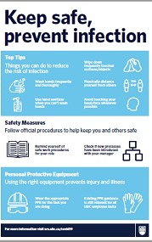
Appendix C
Will be placed at all front
entrance points. Including grounds – these will be on movable sandwich boards.
Will be placed on movable sandwich boards near entrance and venue areas.
Will be placed in all washrooms. Kitchen, and staffing areas.
Placed throughout venue area, and grounds – on movable sandwich boards, walls and popsicle signage stands.

Will be placed on movable sandwich boards near entrance and venue areas.

Additional Signage to include but not limited to
Individual Event Floor Plans with Guest Names and Placement.
Floor decals and signage noting one‐way walkways and access points.
Signage for washroom line ups ad floor markers for distancing.
Signage asking guests to stop and use hand sanitizer before they enter or exit the venue area (hand sanitizer supplied).

Appendix C: Signage and Placement
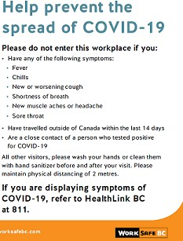
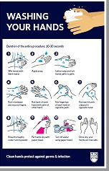
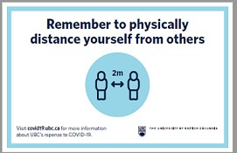

Appendix D
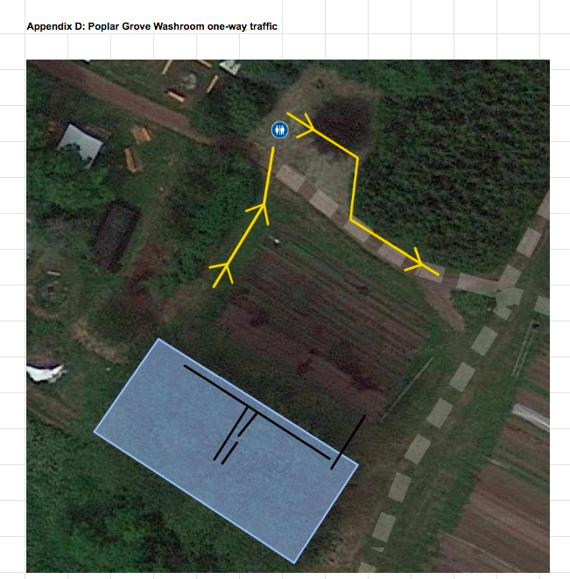

Appendix D

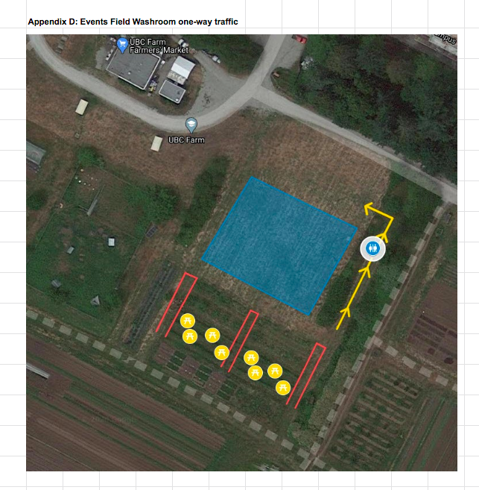

Appendix E - Sample Floor Plan
Max Capacity 50 guests - seating in Poplar Grove venue
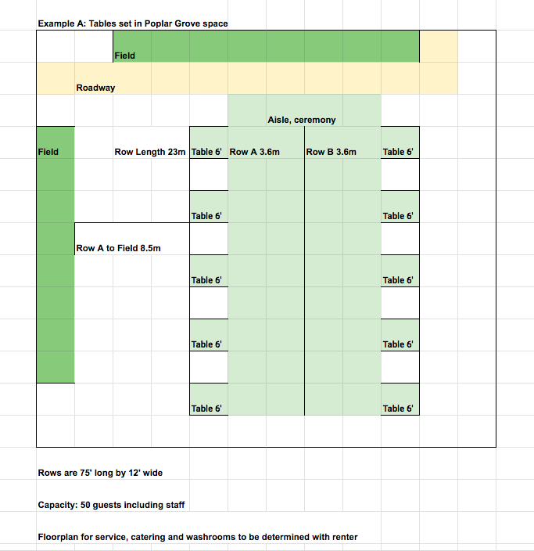

Appendix E - Sample Floor Plan
Max Capacity 50 guests - seating on outdoor covered terrace

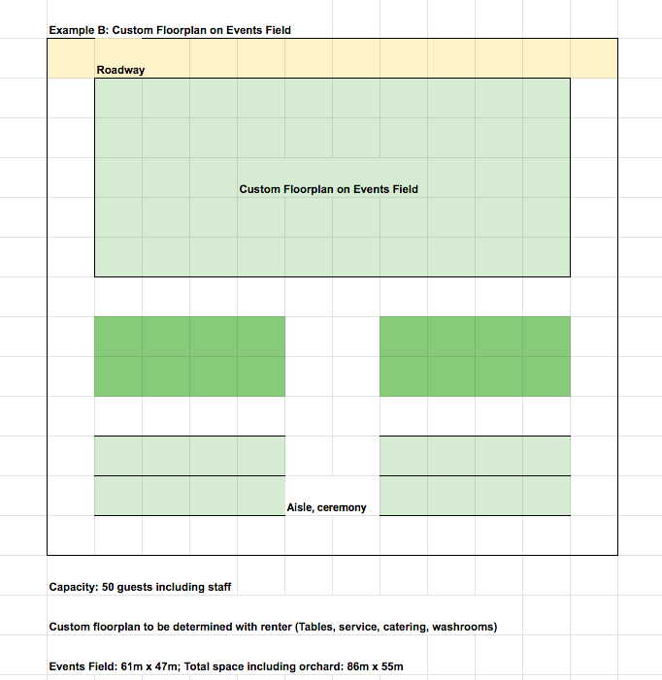
Appendix F

UBC Farm COVID‐19 Filming Plan
When filming is booked at UBC Farm, the productions must follow all worksafeBC guidelines including maximum staffing and social distancing measures. Productions must submit and have approved a COVID‐19 safety plan through the UBC Film and Event Office this plan will include but not limited to;
  - Confirmation of how many crew members will be onsite at any given time.
  - Full COVID‐19 health and safety plans and precautions.
  - List of crew members who have traveled outside of Canada and The Province of British Columbia and confirmation of their pre‐shoot quarantine when applicable.
  - Approved site foot print.
  - Approved pre and post cleaning measures.
When onsite, all production crews will be working within an approved area, essentially creating a bubble. We ask that UBC staff do not enter into this area, and the crews not enter into the outlined designated area(s) for UBC/UBC Farm Staff.
When working onsite production crews will be asked to do the following;
  - Create fencing, roped off and/or coned barriers indicating filming bubble.
  - Create and post site maps and directional signage indicting where crew members and the UBC Farm staff can go to access filming areas.
  - Staff individuals to monitor and maintain these areas.
  - All crews outside, or not in the camera shot will be asked to wear masks.
UBC Farm staff will have clear, defined areas that are large enough to allow safe social distancing to access all work areas.
Additional requirements on productions to include but not limited to;
  - All productions will be prohibited to using any items that create smoke or vapour, this includes but is not limited to atmospheric smoke.
  - Full and detailed filming plans will be shared with all staff, within a minimum 3 ‐5 days prior to filming.
  - All productions must have their technical walk throughs and initial plans to UBC building operations at minimum 8 ‐ 10 days prior to filming.
  - A minimum 4 ‐5 days will be placed between film production bookings at the UBC Farm.
  - Additional load in and load out days will be booked by production to accommodate the time needed to fully clean and set and reset the UBC Farm venue area.

Appendix G
!

Glove removal procedure

To protect yourself from exposure to contamination, you must take your gloves off safely.

How to remove gloves safely

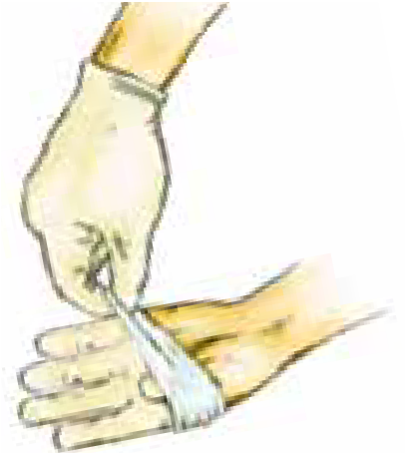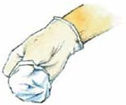

1. With both hands gloved, grasp the outside of one glove at the top of your wrist.

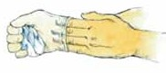
4. With your ungloved hand, peel off the second glove by inserting your fingers inside the glove at the top of your wrist.
2. Peel off this first glove, peeling away from your body and from wrist to fingertips, turning the glove inside out.

5. Turn the second glove inside out while tilting it away from your body, leaving the first glove inside the second.

7. Wash your hands thoroughly with soap and water as soon as possible after removing the
gloves and before touching any objects or surfaces.
3. Hold the glove you just removed in your gloved hand.

- Dispose of the gloves following safe work procedures. Do not reuse the gloves.

Page 1 of 1
Workers’ Compensation Board of B.C.

PPE 09-015

Appendix H

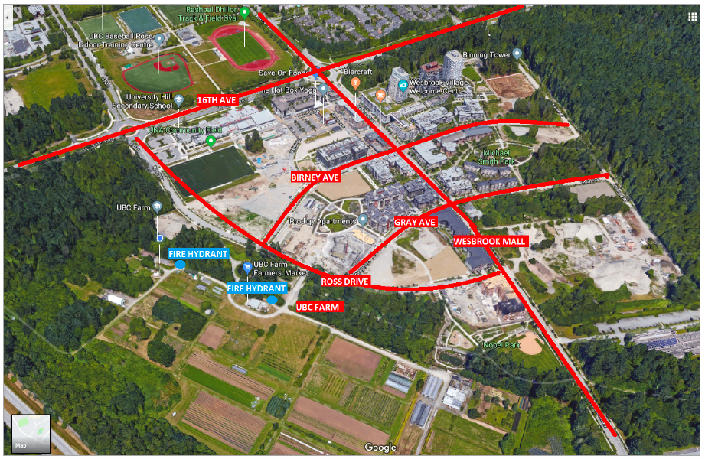

Appendix I
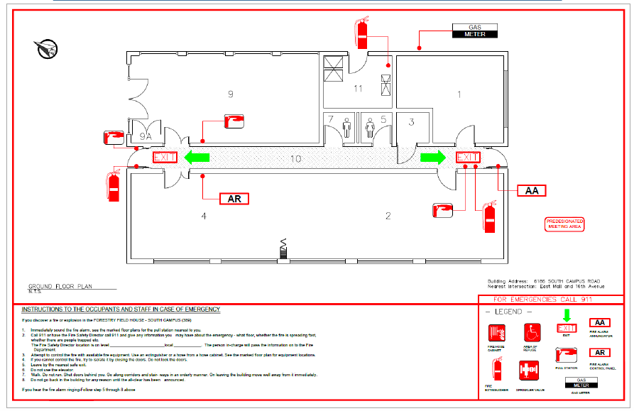

Appendix J  Task  See Guidance Document Appendix B | Hazards and possible outcomes  See Guidance Document Appendix B and C | Pre‐Control Risk  See Guidance Document Appendix E |  |  | Controls  (Detail all controls that will be used to minimize the risk due to the hazard) See Guidance Document Appendix F and G | Post‐Control Risk  See Guidance Document Appendix E
 |  | Consequence  See Guidance Document Appendix D | Likelihood  See Guidance Document Appendix D | Risk Level  See Guidance Document  Appendix E |  | Consequence  See Guidance Document Appendix D | Likeli-hood  See Guidance Document Appendix D | Residual Risk Level  See Guidance Document  Appendix E
Supervising Load In/Load
out of events
1) Unlocking gate or equipment areas. | Touch Point (COVID‐ 19)  ‐ | If infected with covid‐19 person can become a carrier or fall ill with COVID‐19 which could be mild or severe and can lead to community  transmission | Rare and Unlikely | Medium | Staff are instructed to wash hands once they have unlocked and disabled alarm.  Touch points are cleaned regularly by staff and BOP.
2) Set up event specific signage and equipment | Ergonomic – strains Environment – sun, heat  Terrain – uneven slippery | Irritation or physical discomfort | Rare/Unlikel y | Low | Staff are instructed to only lift one sandwich board or table at a time. Use of hand tracks or carts is encouraged for moving multiple items.  There is adequate time scheduled to take their time and not be rushed to complete the task. They are  asked to dress for outdoor work, including closed toe shoes.
3) Review floor plan  – adjust if necessary. | Ergonomic – strains Environment – sun, heat  Terrain – uneven slippery | Irritation or physical discomfort | Rare/Unlikel y | Low | Staff are
instructed to wear
appropriate foot wear, not be rushed and make
sure if they are required to lift heavy items, to review safe lifting procedure posted on Health and Safety boards around the UBC Farm.

Risk Asse
ssment Templa
te
Page 1 of 4
Template prepared by: Safety & Risk Services Last Reviewed: Nov 26, 2018

 |  |  |  |  | anything to do so safely.
4) Assign event security guard | COVID‐19  transmission | If infected with covid‐19 person can become a carrier or fall ill with COVID‐19 which could be mild or severe and can lead to community transmission | Rare/Unlikel y | Medium | Social distancing measures of 2 meters must be maintained. Staff to review security guard placement and event details. And provide onsite event cell # ‐ all instructions during event will be through text/cell  call.
5) Greet vendors & Client | COVID‐19  transmission | If infected with covid‐19 person can become a carrier or fall ill with COVID‐19 which could be mild or severe and can lead to community transmission | Rare/Unlikel y | Medium | All load in and floor planning will have been shared digitally and meeting will have been done virtually before event date.  Vendors have floor plan and scheduled time to deliver – NO physical contact needed – Social distancing of minimum 2 meters held at all  times.

Page 2 of 4
Template prepared by: Safety & Risk Services Last Reviewed: Nov 26, 2018

6) Set up / Tear Down AV and rented equipment. | Touch Point (COVID‐ 19) | If infected with covid‐19 person can become a carrier or fall ill with COVID‐19 which could be mild or severe and can lead to community transmission | Rare/Unlikel y | Medium | Facility staff are required to wear gloved when setting up or tearing down equipment.  Gloves must be disposed of immediately, safe procedure signage located next to equipment and staff areas.  Equipment to be wiped down with alcohol or bleach sanitizer with the set  up and take down.
7) Event supervision | COVID‐19  transmission Working Alone Violence/Emergency | With multiple groups and clients on site COVID‐19  transmission is possible.  Alumni facility staff will be working alone. Violence or Emergency is always a risk in a social event. |  |  | A minimum of one non-event staff will be onsite for all social event bookings. A UBC Security guard may be required for some bookings. In case of medical emergency they will call 911 – they  are not to provide

Page 3 of 4
Template prepared by: Safety & Risk Services Last Reviewed: Nov 26, 2018

basic first aid. Facility staff will call UBC security in a case where there is a risk of violence and or if client/guests do not adhere to capacity and
curfews etc.

Risk Assessment Template

Page 4 of 4
Template prepared by: Safety & Risk Services Last Reviewed: Nov 26, 2018

Appendix K

Safe Work Procedure Template

Purpose
This document describes the safe working procedures for UBC Farm staff members to supervise on site meetings or events at UBC Farm – with proper safety procedures in place during the COVID-19 pandemic.

Scope
This document applies to all UBC Farm staff, UBC staff, and any vendors who are working in or around the event facility of UBC Farm.

Regulations
- WorkSafeBC Occupational Health and Safety Regulation
- COVID-19 Safety Plan outlining policy, guidelines and procedures in place for UBC Farm. (Posted on website)

Definitions
Administrative Controls: The modification of work processes or activities to minimize risk
Engineering Controls: The modification of the physical work environment to minimize risk
Hazard: A potential source of harm to a person that can lead to a risk of injury or occupational disease
Risk: The chance of injury or occupational disease
Risk Assessment: The process where hazards are identified, their risk evaluated, and controls for the risk are determined to eliminate the hazard or minimize the risk
Supervisor: The person directly responsible for overseeing the tasks of the worker
Worker: All employees of UBC including faculty, staff, and paid students

Page 1 of 6
Template prepared by: UBC Safety and Risk Services
Template Review Date: August 13, 2018 | Next Review Date: August 13, 2019

Responsibilities
UBC Farm Team Includes:
Clare Cullen – Operations Director, Centre for Sustainable Food Systems at UBC Farm
Tim Carter – Field Manger, UBC Farm
Jaylin Melnichuk – Site Coordinator, UBC Farm
Anna Legault – Community Events Assistant, UBC Farm

Department Head
- Review and approve safe work procedures outlined in this document prior to their implementation

Supervisor
- Identify all workers who carry out this task under your supervision
- Conduct a risk assessment to identify the potential hazards associated with the task and any related risks
- Implement controls using the hierarchy of controls to minimize the risk due to the hazard
- Ensure safe work procedures are documented
- Ensure proper training has been provided to workers PRIOR to commencing work (e.g.: safe work procedures, use of equipment or tools, personal protective equipment requirements, identifying and reporting hazards, etc.) and that the training has been documented
- Ensure workers have access to and understand any required documentation such as manuals, Safety Data Sheets (SDS) etc.
- Educate workers on emergency procedures, contacts and numbers. If emergency contact information is not posted at the workplace, provide the worker with a copy to carry with them. The worker must know what to do in case of emergency/injury
- Ongoing consultation with Joint Occupational Health and Safety Committee in the review and revision of this procedure to ensure the content is adequate and relevant to current research
- Communicate risks that may arise outside of those that are predetermined

Workers
- Understand and follow this safe work procedure
- Complete the required training for the task
- Use proper personal protective equipment
- Report any unsafe conditions to their supervisor
- Report all incidents in CAIRS

Page 2 of 6
Template prepared by: UBC Safety and Risk Services
Template Review Date: August 13, 2018 | Next Review Date: August 13, 2019

Training Requirements

Training courses for Land and Food Systems staff are recorded in the Training Resource Management System. All staff working at the UBC Farm site are required to complete all required training before accessing the site.

Page 3 of 6
Template prepared by: UBC Safety and Risk Services
Template Review Date: August 13, 2018 | Next Review Date: August 13, 2019

Materials/Equipment
See Appendix G for guidance.
- PPE includes gloves, hand sanitizer
o Does not include masks in outdoor spaces, but a conversation will be facilitated with staff and management about masks during these activities. No restrictions will be in place if staff feel comfortable or want to wear masks in non-mandatory contexts. We will continue to follow UBC policy regarding masks.
- AV and Rentals – portable microphone and sound system, tables, chairs will need to be set up as needed
- Sandwich boards will need to be set up

Safe Work Procedure

Before Commencing Work:
- Staff will review how they are feeling. If they have a fever, chills, muscle or head ache, new or worsening cough or sore throat they will be asked NOT to come to work and to inform their supervisor immediately.
- Site and events staff must review event plan and workplace safety plan to ensure they are versed in all the event details and social distancing and safety measures set in place.

Commencing Work/Work Procedure:
- Review floor plan and signage requirements.
- Greet at a social distance both vendor(s) and client.
- Be on hand to assist with questions about facility (e.g.: outlet locations) etc.

Post Procedure:
- Ensure that all guests have left the facility; perform closing duties and lock up, and email or text supervisor the event end time.
- Write up post event notes within 24 hours of end of event.

Other Important Information

Page 4 of 6
Template prepared by: UBC Safety and Risk Services
Template Review Date: August 13, 2018 | Next Review Date: August 13, 2019

Emergency Rescue and Evacuation Procedures
See Appendix I for guidance.

Emergency Contact Information
- 911 for all medical emergency
- 911 fire department
- 911 police
- 2-2222 UBC Security

Mode of Emergency Communication
- Cell Phone
- Landline in Harvest Hut
- Landline in Farm Centre Office

First Aid
• 2-4444 (for UBC Employees)

Emergency Procedures
- First aid is not to be used or performed on guests or non UBC employees. During COVID-19 light first aid for cuts and bruises etc. must be applied by the guest/client/family member of guest – a small first aid kit will be available for use. All other medical emergencies will require a call to 911.

Training Requirements

Onsite Trained Specialists

Page 5 of 6
Template prepared by: UBC Safety and Risk Services
Template Review Date: August 13, 2018 | Next Review Date: August 13, 2019

Review and Retention

This SWP is reviewed annually or whenever deemed necessary by the responsible departmental representative.
Document Approval Signatures

Signature of Supervisor
Signature of Department Head

Date
Date

_________________________
Name of Supervisor
Name of Department Head

** to be signed with full approved document from steering committee
This signature confirms that this document has been reviewed and approved as per the process detailed in Figure 1 of the Safe Work Procedure Guidance Document

Page 6 of 6
Template prepared by: UBC Safety and Risk Services
Template Review Date: August 13, 2018 | Next Review Date: August 13, 2019

Appendix L: UBC Farm – COVID-19 Guided Tour Guest Agreement

The safety of our clients, guests and staff members is our top priority. High standards of hygiene and cleanliness are in place within the facility, along with physical distancing measures and reduced capacities. We need your commitment and support to ensure that we are all doing our part to protect the spread of COVID‐19. Please be prepared to take the following measures when you are participating in any activity at UBC Farm.

- Tour groups are limited to 15 guests, plus one UBC Farm tour guide. This does not include children under 10 years of age from the same household as a tour guest.
- All staff and guests are asked to not enter UBC Farm if they have any of the following symptoms:

*Fever * Chills * New or worsening cough * Shortness of breath * New muscle ache or headache * Sore throat * Please note that if you are displaying these symptoms you will be asked to leave the meeting or event; no exceptions will be made.

or

  - Have travelled outside of Canada within the last 14 days.

  - Are in close contact of a person who tested positive for COVID‐19.

- Please wash or clean hands with sanitizer before (and after) you enter the site. We encourage you to bring personal hand sanitizer with you.

4. Maintaining a physical distance of 2 metres with anyone who is not in your household is important at all times.

Tour Group Guest Communication

- A confirmed guest list will be included with your tour booking, or sent to the UBC Farm Site Coordinator via email, as soon as possible, and no later than 48-hours prior to the tour. The leader or representative of the group will collect a phone number or email address from each tour guest for contact tracing, to be provided to the UBC Farm Site Coordinator.
- The client, planner or representative will share this UBC Farm COVID‐19 Tour Group Agreement document TO ALL GUESTS, prior to their arrival.
- You understand that if your event exceeds maximum event capacities of 15 guests (not including children under 10), the tour will not be permitted.
- ANY guests displaying the following symptoms ‐ Fever * Chills * New or worsening cough * Shortness of breath * New muscle ache or headache * Sore throat *‐ will be asked to leave; no exceptions will be made.

The client’s signature on this document denotes the Client’s acceptance of all the terms and conditions set out in this commitment. Client Name (please print)

Signature Date

Additional Housekeeping Notes:

- Smoking is permitted in the parking lot outside of the Farm gates.
- UBC Farm parking is limited – please refer to our website for neighborhood parking options.

We look forward to welcoming you to the Farm, and thank you for keeping your safety and the safety of all a priority.

