UBC Farm COVID-19 Health & Safety Plan - REVISED and ACTIVE
June 3, 2020 – v1
Reviewed by the LFS JOHSC June 4, 2020
Submitted to the CMT and Dean Rickey Yada June 5, 2020

Table of Contents

Introduction 1
Site & Building Access 1
Self-Isolation 2
Physical Distancing 3
Sanitation 4
Hand Washing 4
Personal Health 4
Emergency Procedures 5
Appendix 1: Resources 6
Appendix 2: Sanitation Procedures and Occupancy Guidelines for Farm Spaces 7
Appendix 3: Multi-Vendor Market Plan (approved May 28) 12
Appendix 4: U-Pick Plan (proposed to CMT) 23
Appendix 5: Previous Plan (approved March 26) 28

Introduction
The UBC Farm is committed to the health and safety of our employees and the community that we serve. In order to continue to safely produce fresh produce for the local community, we are implementing protocols to ensure we can safely work on site together while doing our part to limit the spread of COVID-19.

I confirm that this Safety Plan has been shared with staff both through email and will be made available as a shared document. Staff will provide confirmation that they have received and read the document.

Date: June 5, 2020
Name: Clare Cullen
Role: Operations Director

About This Document
This document outlines our general COVID-19 health and safety policies, and the appendices provide more specific and detailed guidance for on-site safety that will be updated on an ongoing basis as conditions change, following recommendations from the Government of British Columbia, WorkSafeBC, and UBC.

This document replaces the previous COVID-19 Farm Safety Plan approved on March 25, 2020 (appendix 5). It complements but does not replace other health and safety training, rules, procedures, and policies including UBC’s Occupational and Research Health and Safety Policy SC1, health and safety training provided by UBC Safety and Risk Services, and site and task specific training provided by the UBC Farm.

All UBC Farm employees are encouraged to participate in the ongoing development of health and safety practices at the UBC Farm. This plan is a result of such broad-based participation, and it will continue to be updated in collaboration with the Centre for Sustainable Food Systems Management Team, the UBC Farm Local Safety Team (LST) and the Faculty of Land and Food Systems Joint Occupational Health and Safety Committee (JOHSC). Employees should share specific concerns about and suggestions for this plan with their supervisors and/or with their representatives on the UBC Farm LST and the Faculty of Land and Food Systems JOHSC.

This is a public document and will be accessible on the UBC Farm website. Physical copies may be viewed on site upon request. All UBC Farm employees must read and agree to participate in the implementation of this plan before beginning or resuming working on site. Employees must also complete any new, relevant training modules from UBC Safety and Risk Services in a timely manner and upload their certificates to the Land and Food Systems Training Record Management System.

Site & Building Access
Site Access
Access to the UBC Farm site is restricted to the following activities and will remain so until further notice:
- Food production, food distribution, approved critical research support, and essential site maintenance and administrative activities by UBC Farm employees.
- Essential facility support activities by Building Operations, Energy and Water Services, and other service personnel.
- Cultural practices by Indigenous program participants (e.g. food and medicine cultivation) in a maximum group size of four.
- Monthly bird surveys by Nature Vancouver participants in a maximum group size of three.
- On-site research by researchers listed on an approved research curtailment exemption or an approved research safety plan.
- Domestic activities by resident UBC Farm caretakers and their essential service providers (e.g. accessing and maintaining caretaker trailers and vehicles, accessing caretaker storage, providing child care, using shared laundry facilities, etc.).
- Pickup of produce orders and donations outside the Harvest Hut at pre-arranged times by Farm customers and food distribution providers.
- Shopping at approved UBC Farm markets by the general public (appendix 3).
- Harvesting and purchasing produce at approved u-pick events by the general public (appendix 4).
- Delivery of essential supplies and equipment by couriers and vendor delivery personnel.
Building Access
Access to buildings at the UBC Farm is restricted to the following activities and will remain so until further notice:
- Food production, food distribution, and essential site maintenance and administrative activities by UBC Farm employees.
- Essential facility support activities by Building Operations and other service personnel.

Self-Isolation
Employees and everyone with permission to access the site are required to follow current BC Centre for Disease Control guidelines on self-isolation and self-monitoring. Anyone accessing the site must first screen themselves for potential COVID-19 symptoms (e.g. feeling unwell, frequent coughing, frequent sneezing, or fever), and anyone who is displaying potential COVID-19 symptoms will be advised to leave the site. Employees who are unable to work on site due to the need to self-isolate should communicate with their supervisors about the options available to them for wage continuity during their self-isolation period. Options vary by employee group and may include working remotely (including alternate duties and professional development activities), sick leave, and various forms of time off.

The university has approved temporary measures for employees who do not have access to paid sick leave as part of their employment, as well as those who have used up their paid sick bank. Operational units have been directed to provide paid sick leave for COVID-related symptoms until June 30, 2020 for up to 10 consecutive days within the 14-day self-isolation period. For employees who have sick leave provisions as part of their employment but have used up all of their sick leave, any sick time taken will be deducted from their future sick leave accruals.

Physical Distancing
All persons on site must maintain an approximately two-metre distance at all times from anyone who is not a member of their household. In the rare event that other safety considerations require two people to be in close proximity to complete a given task (e.g. lifting a heavy object safely), they must wear respirators or face masks while engaged in this task. As always, the full hierarchy of controls (elimination, engineering controls, administrative controls, and personal protective equipment) must be considered before resorting to personal protective equipment. For stationary tasks such as cashiering at a market, an engineering control such as a barrier should be employed unless it would create an additional safety hazard.

To prevent accidental lapses in physical distancing on site, the number of people occupying given spaces on site must be limited. The responsibility to develop and communicate occupancy guidelines for spaces is assigned to wardens (Appendix 2). The exact number of people allowed in a space will depend on a number of factors including the layout of the space and the circulation needs of the activities associated with that space.

Anyone accessing buildings on site is encouraged to take special care when navigating entrances/exits, corridors, and blind corners. If the maximum occupancy for an indoor space has been reached and another person attempts to enter the space, those already in the space should politely communicate this to the person attempting entry. One or more Farm employees may need to temporarily vacate an indoor space if access is required by Building Operations or other essential service staff.

If significant or recurring minor lapses in social distancing are experienced on site, they should be reported to the wardens of the space in which they occurred. Employees should also report such incidents to their supervisors.

The combination of reduced site access and physical distancing has the potential to create situations in which UBC Farm employees or researchers are working alone. If such situations occur, Farm employees must follow procedures for working safely alone including having their two-way radios on their person, checking in regularly with their supervisor, and indicating to their supervisor when they are no longer working alone by using radio or cell-phone text. Similarly, researchers working alone on-site will need to inform their research supervisors or the CSFS research manager (Laura Morillas), or whichever is detailed on their research exemption (if different), at the time they access the site, every two hours, and at the time they leave the site.

Sanitation
For the purposes of the plan, there are two sides of sanitation: minimizing and sanitizing. Minimizing refers to minimizing the number and intensity of use of common touch surfaces. Minimizing is achieved by assigning spaces and equipment to designated users and restricting access and use by others. Sanitizing refers to cleaning and sanitizing those common touch surfaces that are unavoidable. The frequency of sanitizing common touch surfaces is dependent on the intensity of use.

All employees are expected to participate in sanitation practices on site. Daily responsibility for sanitation is divided up by unique Farm space and is assigned to wardens. Warden assignments and responsibilities are located in appendix 2.

Hand Washing
All persons on site must wash their hands thoroughly and frequently, including at the following times:
- Upon arrival on site
- Before and after eating
- Before and after touching their face or a face mask or respirator
- Before and after work at their assigned workstation
- After using the washroom
- After touching items that have recently arrived on site (e.g. shipments, mail, cash, returned totes or crates)
- Before harvesting or handling food
- Before entering food storage and handling spaces

Five outdoor hand washing stations have been set up and distributed around the site to facilitate this practice. Hand washing should be performed according to the instructions posted at these stations. Note that while warm water may make hand washing more pleasant, it does not make hand washing more effective unless your hands are covered in grease, fat, or oil.

Personal Health
Avoiding illness starts with living well. As important as it is to minimize exposure to potential sources of COVID-19 transmission, it is also important to take positive actions that promote physical wellbeing, mental health, and nutritional health.

The UBC HR website has some helpful guidance for living well in this time of crisis. Key points include the following:
- Stay connected
- Recognize the impact of isolation
- Care for yourself and encourage others to do the same
- Access resources to enhance your mental health
- Acknowledge that work will be impacted

http://www.hr.ubc.ca/wellbeing-benefits/living-well/mental-health/staff-faculty/

Emergency Procedures
- Maintain and adhere to the UBC Farm Building Emergency Response Plan (BERP) (last updated May 29, 2020). Note that physical distancing is not required during an emergency evacuation. The primary goal in an emergency situation shall always be to evacuate the building expeditiously and meet at the muster point.
- Communicate the Farm’s muster point to all site users, which is located inside the main gate and indicated with a large sign.
- Call emergency response in case of urgent medical or safety situations:
- Occupational First Aid (Vancouver Campus) 604-822-4444
- Hazardous Material Response (Vancouver Fire & Rescue Services) 911
- UBC Hospital Urgent Care (8:00 a.m. – 10:00 p.m.) 604-822-7662
- Poison Control Centre 604-682-5050
- Campus Security (For an Emergency call 911) 604-822-2222
- Fire, Police, or Ambulance: 911
- What information is required when I dial 911?
- Describe the Emergency
- Location
- Building Name
- Building Address & Room
- # Phone Number
- Do NOT hang up as additional information may be needed

Appendix 1: Resources
https://covid19.ubc.ca/
https://srs.ubc.ca/health-safety/health-safety-covid-19/
https://riskmanagement.sites.olt.ubc.ca/files/2020/04/COVID-19-PPE-Guidance_final.pdf
https://www.worksafebc.com/en/about-us/covid-19-updates
http://www.bccdc.ca/health-info/diseases-conditions/covid-19
https://instituteforfoodsafety.cornell.edu/coronavirus-covid-19/food-industry-resources/
https://bcfoodweb.ca/covid-19-resources
https://bcfarmersmarket.org/bcafm-covid19/
https://ready.ubc.ca/wp-content/uploads/2020/03/Washing-hands-poster_11x17.pdf
http://www.hr.ubc.ca/wellbeing-benefits/living-well/mental-health/staff-faculty/

Appendix 2: Sanitation Procedures and Occupancy Guidelines for Farm Spaces
All UBC Farm employees are responsible for contributing to their own safety and the safety of others through cleaning and sanitizing appropriate items after use, consistent hand-washing, and maintaining physical distancing of approximately two metres. Wardens have been appointed to distinct Farm spaces in order to monitor these practices, ensure daily sanitization, and maintain availability of sanitization equipment. These procedures and guidelines are subject to change and must be updated to reflect current site activity and in accordance with new relevant regulations or official guidance.

Warden Responsibilities:
- Ensure all high touch items in your space are cleaned as needed and sanitized at least one time per day with a sanitizing solution.
- Ensure that sanitizer spray bottles are available in your space and are stored outside of direct sunlight.
- Develop and communicate occupancy guidelines for your space.
- Assign spaces and equipment to designated users as appropriate. Communicate use restrictions.
- Rearrange the layout of furniture and equipment in spaces as needed and appropriate to facilitate physical distancing.
- Monitor that safety protocols are being followed in your space.
- Report unsafe conditions in your space, and participate in resolving them.

Sanitizing Equipment :
Warden: Kyne Tsai
Sanitizer Dilution Rate: 1.5 ml of 12% sodium hypochlorite bleach per 750ml of water
Responsible for refilling sanitizer spray bottles with fresh sanitizer solution as needed to meet demand and maintain sanitizer efficacy.
Farm Centre Kitchen, Hallway, Bathroom, Laundry, Marquee, Children's Greenhouse
Wardens: Alex Pomeroy, Tim Carter, and Jaylin Melnichuk
Daily Sanitize: Afternoon
Maximum Occupancy Guidelines:
- Kitchen & Field Offices: 7
  - Except as needed for medical reasons or for work tasks of short duration, only those employees with assigned workstations in the Farm Centre are permitted to enter it.
- Children’s Greenhouse: 12

Assigned Spaces and Equipment
- Employees with assigned workstations in the Field Offices: Tim, Alex, Mel, and Hannah.
- Employees with assigned seats/tables in the Children’s Greenhouse: Marika, Kyne, Rae, Tim, Alex, Mel, Hannah, Alisha, and Evan.

Common Touch Surfaces to Sanitize:
- Door Handles
- Light Switches
- Appliance controls and handles
- Tables
- Counters
- Paper Towel Dispensers
- Soap Dispensers
- Sink Taps
- Toilet Paper Dispensers
- Washer/Dryer controls and handles

Farm Centre Office
Wardens: Marika Dunham and Rae Cramer
Daily Sanitize: End of Day
Maximum Occupancy Guideline: 4 people
Assigned Spaces and Equipment
- Employees with assigned workstations in the Farm Centre Office: Marika, Kyne, Rae, Elena, Clare.
Common Touch Surfaces to Sanitize:
- Door Handles
- Light Switches
- Work Stations
- Printer
- Phone
- Supply Drawers
- Blinds Pull-String
- Alarm Pad
Yurt and Children’s Garden
Wardens: Hannah Lewis, Jenn Bywater, Noah Zimberoff
Maximum Occupancy Guideline: 8 people

Assigned Spaces and Equipment:
- Employees with assigned seats/tables in the Yurt: Noah, Jenn, Ellie, McKenzie, Audrey, Evguenia, Adam,Jessy
Daily Sanitize: End of Day
Common Touch Surfaces to Sanitize:
- Door Handles
- Light Switches
- Tables
- Chairs
- Outside Wash Station
- Outhouse door
- Outhouse Toilet Paper Dispenser
Seedling Greenhouse and Header House
Warden: Melanie Sylvestre
Daily Sanitize: Afternoon
Maximum Occupancy Guideline: 4 people
Common Touch Surfaces to Sanitize:
- Door Handles
- Light Switches
- Watering Hose
- Watering Can
- Egg Fridge

Seed Processing Hoophouse
Warden: Melanie Sylvestre
Daily Sanitize: Afternoon
Maximum Occupancy Guideline: 4 people
Common Touch Surfaces to Sanitize:
- Door Locks
- Germination Chamber Lock
Toolshed and Hand Tools
Warden: Evan Goh
Daily Sanitize: End of Day
Maximum Occupancy Guideline: 2 people
Common Touch Surfaces to Sanitize:
- Door Handles

High-contact tools or equipment (i.e. hearing protection, face shields) that must be sanitized after each use:
- Hardhats with face shields
- Push mower
- Weedwacker

High-contact tools or equipment that will be assigned one per worker as needed:
- Leather/gardening gloves
- PPE such as safety glasses, hearing protection, or respiratory protection.

Other tools or equipment deemed low risk do not need to be sanitized after each usage, however hand washing is required after use:
- Hand tools (ie hand hoes, shovels, wheel hoes)
- Infrequently used special equipment (i.e. drills, post pounder, irrigation equipment)

Note: Researchers and Indigenous program participants do not have access to the UBC Farm Tool Shed. If they need to use any farm tools, they must consult directly with the warden for them to evaluate if there are safe ways to provide use of tools. Priority for tools use will be given to the Farm Operations team. If temporary use of any tools is granted, those using the tools will adhere to the safety protocol as described above with the guidance of the warden.

Membrane and Tractors
Warden: Alisha M’Lot
Daily Sanitize: End of Day
Maximum Occupancy Guideline: 5 people

Common Touch Surfaces to Sanitize:
- John Deere, Mama Bota, Baby Bota Tractors
  - Steering wheel
  - Gear Shift
  - Accelerator
  - Seat
  - Hand brake
  - Ear Muffs
  - PTO lever
  - Implement lift lever
  - Key
- Grillo Walk-Behind Tractor

Harvest Hut, Coolers, Wash Tents, Field Handwash Stations
Wardens: Marika Dunham and Team
Daily Sanitize: End of day / End of use of Harvest Hut facilities
Maximum Occupancy Guideline (inside): 8 people
Hands must be washed with soap immediately prior to entering the food processing space, including the coolers, tented space and interior of the Harvest Hut.

Single-use gloves must be worn when bagging produce that is likely to be eaten raw and unwashed (e.g. salad mix).

Common Touch Surfaces to Sanitize:
- Harvest Hut Interior
  - Door Handles
  - Light switches
* Remember inside cooler switches!
  - Table & Counter Surfaces
  - Garage Door Chain
  - Drawer Handles
  - Computer Workstation
  - Scales
- Harvest Hut Exterior
  - Cooler Handles
  - Door Handles
  - Hose
  - Wash Stations (3)
    - Sink Taps
    - Paper Towel Dispensers
    - Soap Dispensers
  - Counter tops & Tables
  - Harvest Cart Handles

Appendix 3: Multi-Vendor Market Plan
Approved May 28, 2020 by the UBC President and CMT

Markets will be held in compliance with the approved COVID-19 Farm Safety Plan, including the maintenance of provincially mandated distancing and hygiene requirements. Additionally we will follow further guidelines laid out by the Province for food retailers including markets, and the recommendations from the BC Association of Farmers’ Markets (BCAFM) and the Vancouver Farmers Markets (VFM).

This document outlines the rationale of why our markets are essential and how we plan to adapt operations to ensure worker and public safety.

Role of Markets in the Community
Farmers’ markets are first and foremost food retail establishments for people to purchase high-quality local and sustainable food. Markets also support livelihoods for local farmers and food producers who have been included as “essential services” by the Province.

The UBC Farm has held markets on site for almost 20 years. Our markets are established as an important access point for fresh produce to residents in the University Neighbourhoods Association (UNA) and the growing Wesbrook Village; students, faculty and staff including their families living on campus; and residents of the University Endowment Lands (UEL) , Dunbar and Point Grey neighbourhoods.

The COVID-19 crisis has highlighted the lack of fresh food outlets in these areas, particularly Wesbrook and UBC campus where there is only one grocery store, which has experienced long line ups and shortages of certain products from the start of the crisis. At a time when many food outlets are closed both on and off campus, the UBC Farm Farmers’ Markets will provide much-needed access to fresh produce. While community members normally appreciate the social aspects of farmers’ markets, this season, in compliance with provincial regulations, all elements that encourage a “social” environment will be eliminated and only food and consumables will be available for purchase.

UBC Farm Market Overview

The UBC Farm normally hosts three markets per week during the growing season, beginning in early June and running until late November, providing food to approximately 20,000 customers per year. Our Saturday Farmers’ Market at the UBC Farm is the largest, with 18 to 22 local food vendors per week in addition to UBC Farm produce and CSA pickup (UBC Farm CSA members receive a weekly share of produce). We also have two UBC Farm-produce only markets, one on Tuesday evenings at the UBC Farm, including CSA pickup, and one outside the UBC Bookstore on Wednesdays.

Based on the safety measures being taken by BCAFM and VFM and our own capacity to implement changes to market structure here at the UBC Farm, we are confident that we could safely execute our Tuesday and Saturday on-site markets. We will assess the possibility of a Wednesday, main-campus market based on further developments in terms of UBC policies and a determined need for this food outlet.

UBC Farm Farmers’ Markets as safe and stable food access point

The B.C. Ministry of Agriculture has determined that under additional conditions regarding COVID-19, Farmers’ Markets can continue to operate in B.C. at this time. It has also been determined by the BC Centre for Disease Control (BCCDC) that farmers’ markets are a low-risk setting for the transmission of COVID-19, since markets are generally held outdoors and are easily able to physically distance market customers, making them a relatively safe access point for food purchases -- arguably safer than supermarkets. We are following the BCCDC’s instruction and updates closely in order to properly modify our practices, and, similar to other businesses where foods are purchased by the public, requirements for farmers’ markets include physical distancing and restrictions on activities. These requirements are being taken into account and have been implemented into the plan outlined below (Appendix I).

UBC Farm Farmers’ Markets further increase access to fresh produce by providing a 20 per cent UBC student discount through the Alma Mater Society (AMS) as well as a coupon program in partnership with the BC Association of Farmers’ Markets (BCAFM) which supports customers in financial need.

Summary

Our markets are critical for the following reasons:
- They provide access to healthy, fresh food
- The B.C. Ministry of Agriculture has deemed farmers’ markets an essential service
- They support local farmer and producer livelihoods
- For the UBC Farm, approximately 50 percent of our produce sales occur at our markets, generating a substantial portion of the UBC Farm’s revenue and operating budget. Though the UBC Farm sales team is working hard to diversify our sales channels (i.e. through CSA expansion, new wholesale partners), markets remain absolutely essential to our revenue for the fiscal year. CSA expansion is not a feasible alternative to our markets as CSA cannot support the same quantity of sales.
- Our markets provide accessible food to the community, as supported by the 20 per cent student discount and partnership with the BCAFM coupon program
- Our markets allow customers to support local food growers directly, which provides consumers an opportunity to understand fully where their food is coming from and how it is grown
- It is more critical than ever to support local food producers to ensure food security for B.C. communities at a time when import markets are experiencing volatility from this global crisis

The UBC Farm Tuesday and Saturday markets will provide an essential service and greatly benefit the community, our vendors, and the operations of the UBC Farm while maintaining the safety of our community.

Appendix I- Top Risks Associated with Hosting a Market
The top risks associated with hosting farmers markets, in a traditional setting, that we have identified are as follows:
- Transmission through contact with vendor products
- Transmission as a result of socializing at the market or participating in activities

Throughout the following section, you will see that the changes we have made in our market plan ensure that these risks are as low as possible.

Appendix II- How UBC Farm would operate an on-site Multi-Vendor Market
Continuing to host our Saturday multi-vendor market (with required safety changes outlined below) is the most feasible option for business continuity for the UBC Farm and our vendors. Given that the Vancouver Farmers Market has successfully been running outdoor markets in 2020 without pause, we plan to mirror their well-established and proven system in order to provide a safe environment to purchase local produce and food.

We would ensure that our plan follows all restrictions and recommendations made by the BCCDC and the BCAFM, and we continue to monitor policy changes on a daily basis to ensure we are considering the most current recommendations and guidelines.
A. Required changes :
    - Only food & alcohol vendors are permitted to sell at farmers’ markets as determined by the BCCDC.
    - Limit the number of people allowed in the market space at one time. A staff member will be stationed at the Farm gate monitoring the lines within the market, in radio conversation with UBC Farm stall staff, and determining when to let more people enter the market area. Farmers' markets are exempt from the mass gathering order: however, they must comply with physical distancing requirements. Therefore, we will start the season by limiting our market to 50 customers at one time and will only allow more if we can ensure physical distancing requirements can be maintained throughout the market area.

PLEASE NOTE: Our usual attendance at market is approx 75 visitors per hour from 10 am-12 pm and 55 per hour from 12 pm-2 pm (this is averaged across the whole season). By allowing 50 people at a time and encouraging a steady flow, we will not incur large queues.

Our usual market space allocates approx 1400 sq meters for customers. If we provide 1 meter per person, our capacity would be 140 people. This year, in order to offer even more physical distancing opportunities, we will move the market onto our events field which is at least double the usual market space so we could accommodate well over 140 people. Limiting to 50 people will provide each customer and vendors with additional and ample space to distance. (See maps in Appendix VI).

    - “Shop, don’t stop” will be the theme of the year. This means that we will not have music, community tables, or activities and will ask that customers shop for what they need and leave immediately.
    - Two hand washing stations will be available at markets. (See appendix 4).
    - Vendors will be more spread out, to allow for greater physical distancing, with two meters between each stall.
    - Sampling products will not be permitted.
    - Pylons will be put out to make starting points for queues at each stall.
    - We will ask customers to maintain a distance of two meters from the customer before them in any queue. (See staffing considerations in Appendix 3, as Farm staff will be responsible for monitoring physical distancing).
    - Vendors may only serve one customer at a time.
    - Payment machines will be regularly sanitized.
    - Encourage card payment to minimize any handling of cash.
    - Vendors will be required to use sanitizing spray to ensure all surfaces are as safe as possible.
      - High-touch surfaces will be required to be cleaned regularly by vendors (recommended will be once per hour).
    - Food products that cannot be cleaned at home will need to be protected from sources of contamination at all times during storage and display, e.g. dehydrated mushrooms must be pre-packaged, baked goods, which can be packaged upon purchase, require a sneeze guard at the vendor booth.
    - The distribution of communications materials such as magazines and stickers for customers will not be allowed.
    - There will be no seating or gathering areas available at the markets.
    - In accordance with the restrictions outlined by the BCCDC, we will restrict entry to anyone who is ill; vendors, if they are ill, should not attend and customers who are ill will be advised to not enter the farmers’ market.
    - Reusable bags will not be encouraged at our market this year, but are permitted in the market area as long as customers fill the bags themselves and do not place their bags on any surfaces.
    - No dogs or outside animals will be allowed at the market, except for service animals.
    - Customers will be asked that only one person per household attend the market to reduce wait times and facilitate physical distancing.
    - Vendor fees will be paid online, not by cash.

  - Additional changes for consideration:
Our team will evaluate the Market Safety Plan one week after implementation, and regularly thereafter, to ensure efficacy and safety . We will ensure all frontline workers are given a voice to provide feedback on the Market Safety Plan.

Depending on our on-going experience, we are willing to adjust our protocol by including some of the following additional changes, if necessary, and will alert the CMT if we do implement any additional changes.
    - Potential for pre-orders with vendors and a separate line for pre-order pick up
    - Requiring further personal protection equipment – gloves & masks – for all vendors if recommended by BCCDC
    - Limitation of who can use the on-site porta potties – i.e.: vendors and staff only
    - Adding a sanitizing station at the gate, dependent on our ability to obtain hand sanitizer

Appendix III- Economic Impacts
(Text removed due to lack of specific relevance to safety plan.)

Appendix IV- Staffing Plan
All UBC Farm Market staff will wear gloves for any cleaning/contact activities. We will also encourage staff to wear non-medical or homemade masks to limit the travel of respiratory droplets, in accordance with UBC’s Employee COVID-19 PPE Guidance.

UBC Farm Stall Proposed Staffing Plan (subject to change): four positions
Sales Manager – Marika Dunham
- Oversees the cleaning and sanitation of Harvest Hut and UBC Farm stall
- Ensures staff understand and are following our COVID-19 Farm Safety plan
- Oversees that social distancing measures are implemented and followed within the UBC Farm stall

Sales Assistant – Rae Cramer
- Sanitize UBC Farm stall tables and set up with adequate spacing to ensure social distancing
- Regulate the number of customers entering UBC Farm stall to ensure all persons in the stall maintain safe social distancing
- Managing social distancing and safety procedures and providing signage to make these clear
- Regular sanitation of credit card machines
- Collection and sanitization of farmers’ market baskets that have been used by customers
- Take down and sanitization of market equipment

CSA Coordinator – Kyne Tsai
- Managing that CSA members are social distancing
- Ensuring that CSA stall is serving only one member at a time

Additional Support – Two Market Cashier Work Learn Students, two or three trained and experienced market volunteers
- Cashiers regularly sanitize card machines and produce scales
- Cashiers will not handle money and produce within the same transaction. If a cashier has to transition from handling cash/card they must throw away their gloves, wash hands, and put on new gloves before handling produce.
- Volunteers will assist with market set up and re-stocking as needed, they will follow all COVID-19 safety protocol under the supervision of the sales assistant, Rae Cramer, and the sales manager, Marika Dunham

Market-Specific Staffing Plan – four positions
Saturday Market Manager – Carissa Kirk
- Set up & sanitizing of vendor tables with bleach spray
- Maintain that all hand sanitizer and/or hand washing stations are fully stocked
- Setup of pylons to mark the start of the queue for each vendor
- All COVID-19 related market signage up throughout the market space
- Regular check-ins with vendors throughout the market to ensure they are abiding by all safety rules and are comfortable with what has been implemented
- Main point of communication with all vendors to limit overall contact
- Answering customer/vendor questions
- Take down and sanitization of equipment

Market Assistant – Market Assistant Work Learn
- Set up & sanitizing of vendor tables
- Assist with signage
- Responsible for standing at the entrance to control the number of people that enter the market, ensuring there are only 50 at one time
- Answering customer/vendor questions
- Provides safety messaging to those entering the market/market queue
- Take down and sanitization of equipment

Additional Support Persons – Event Assistant Work Learn Student & UBC Security Person
- One person stationed at the front of the market queue telling customers when they can begin shopping
- Other person floating and monitoring customers to ensure:
  - They are following market guidelines
  - Are maintaining safe distances in queues
We have also contacted UBC Campus Security to see if they could support us on Saturdays in ensuring customers maintain proper physical distancing and we are waiting to hear back on their capacity and what this would cost.

In situations where additional support is needed (i.e.: someone is sick or away), the Administration and Site Coordinator, Jaylin Melnichuk, will be able to support this element of the market on Saturdays. Additional support can be requested from the Field Team, including Hannah Lewis who was the previous Market Manager and has offered to support Saturday Markets.

Overall Employee Involvement, awareness and safety

Employee Input/Involvement: Based on WorkSafeBC Phase 2 Guidelines, the development of this plan has directly involved frontline workers, Joint Occupational Health and Safety Committees, and Supervisors in identifying risks, protocols and continued evaluation of these.

In order to receive input from as many staff members as possible, the plan was created as a Google doc where our Field Manager (Tim Carter), Sales Manager (Marika Dunham), Market coordinator (Carissa Kirk) and Sale Assistant (Rae Cramer) worked together to input the initial components of the plan. These were made after research into policies, guidelines and best-practices outlined by BC Government, BC CDC and BC Association Farmers Markets as well as WorkSafe requirements.
The document was then shared with staff on our Management Team as well as our Field Crew to receive additional input.
Tim Carter is our representative on the LFS Local Safety Team, so brought a JOHSC lens to the plan. Once approved, we will share with LFS JOHSC.
During the process, the Operations Director and Academic Directors contributed and reviewed.

All Supervisors have been notified on appropriate Workplace Health measures, which have been shared by email, and are aware of the support available. Supervisors will communicate these to their employees during in-person team meetings, as well as through email. We will also communicate to all staff through our email weekly updates.

We will publish this plan along with our Farm Safety Plan (March 25, 2020) ONLINE on our web-site, as well as in a shared Google doc that all staff can access. We will post HARD COPIES in several locations at our workplace – the Farm Centre and the Harvest Hut – for employees and any others that may need to attend site

This document complements but does not replace other health and safety training, rules, procedures, and policies including UBC’s Occupational and Research Health and Safety Policy SC1, health and safety training provided by UBC Safety and Risk Services, and site and task specific training provided by the UBC Farm. As always, employees are encouraged to participate in the ongoing development of health and safety practices at the UBC Farm.
This is a public document and will be accessible on the UBC Farm website. Physical copies may be viewed on site upon request. All UBC Farm employees must read and agree to participate in the implementation of this plan before beginning or resuming working on site.

We will continue to communicate the risk of exposure to COVID-19 in the workplace to our employees using our weekly email to All Staff; during weekly in-person team meetings; and during our monthly All Staff meetings (currently via Zoom). We will continue to share up-to-date Provincial and Federal resources on COVID 19 as well as conduct-expectations for the employee's physical return to work.

Employees and all with permission to access the site are required to follow current BC Centre for Disease Control guidelines on self-isolation and self-monitoring. Anyone accessing the site must first screen themselves for potential COVID-19 symptoms (e.g. frequent coughing, frequent sneezing, or fever), and anyone who is displaying potential COVID-19 symptoms will be advised to leave the site. Employees who are unable to work on site due to the need to self-isolate should communicate with their supervisors about the options available to them for wage continuity during their self-isolation period. Options vary by employee group and may include working remotely (including alternate duties and professional development activities), sick leave, and various forms of time off. (See Appendix V for Farm Safety Plan excerpt w details)

Should staff have any feedback, questions and/or concerns regarding the Market plan and/ or the Farm Safety Plan, or they have concerns about exposure to COVID 19 in the workplace, they should raise these with their Supervisor directly, and/or with their representatives on the UBC Farm Local Safety Team and the Faculty of Land and Food Systems Joint Occupational Health and Safety Committee.
Employees can also contact the following people:

- Operations Director – Clare Cullen clare.cullen@ubc.ca
- LFS Facilities Manager – Andy Jeffries andy.jeffries@ubc.ca
- LFS HR Director – Barbara Hsiao barbara.hsiao@ubc.ca

The WorkSafeBC Phase 2 Guidance document includes guidelines to address changes due to workplace closure. The UBC Farm did not close down during the pandemic therefore there are no changes in terms of new equipment, staff turnover and worker roles. We do have new protocols pertaining to COVID 19 (see Appendix IV) which we have outlined to staff in person, in weekly email updates and at the All Staff meetings. Any updates to these protocols will be communicated both via these channels as well as through an updated shared Google doc and by publishing updated protocols on our web-site.

Staff who have been working remotely during the pandemic may begin to come on site one or two days per week. They are aware of and will follow all safety protocols.

We understand that an SRS Mandatory Training Module for Employees is being launched this week. We welcome this and we will use the existing training tracking procedures within the Faculty to ensure all staff have successfully completed the COVID-19 ReStart UBC Return to Work online training. We will also set up a Google doc check-list so that staff can self-report that they have completed the training.

Employees must complete any new, relevant training modules from UBC Safety and Risk Services in a timely manner and upload their certificates to the Land and Food Systems Training Record Management System.
Based on the BC COVID-19 Go Forward Management Strategy Risk Matrix, we ascertain the risk to be in the LOW category, particularly as the Modification potential is good for our markets: markets are held outdoors; we can control numbers of people and maintain physical distancing, and we have strong social buy-in from our staff and our customers to follow-the rules as laid out by BC, WorkSafe and UBC in order to ensure the risk is kept low and to see markets continue safely at the UBC Farm.

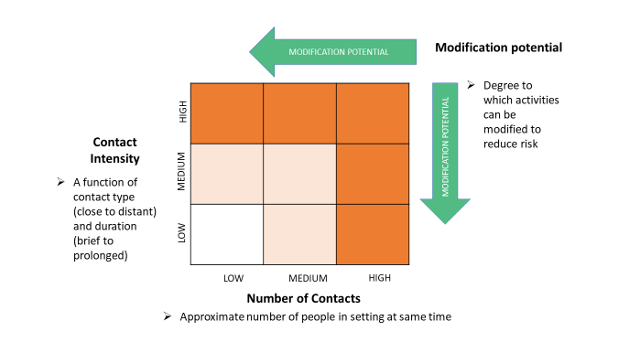

Appendix V – Farm Safety Plan excerpt
(Text removed to avoid duplication)

Appendix VI- Market Maps (Subject to Change)
Option I
Provided construction allows customers to line up on the sidewalk outside the UBC Farm.

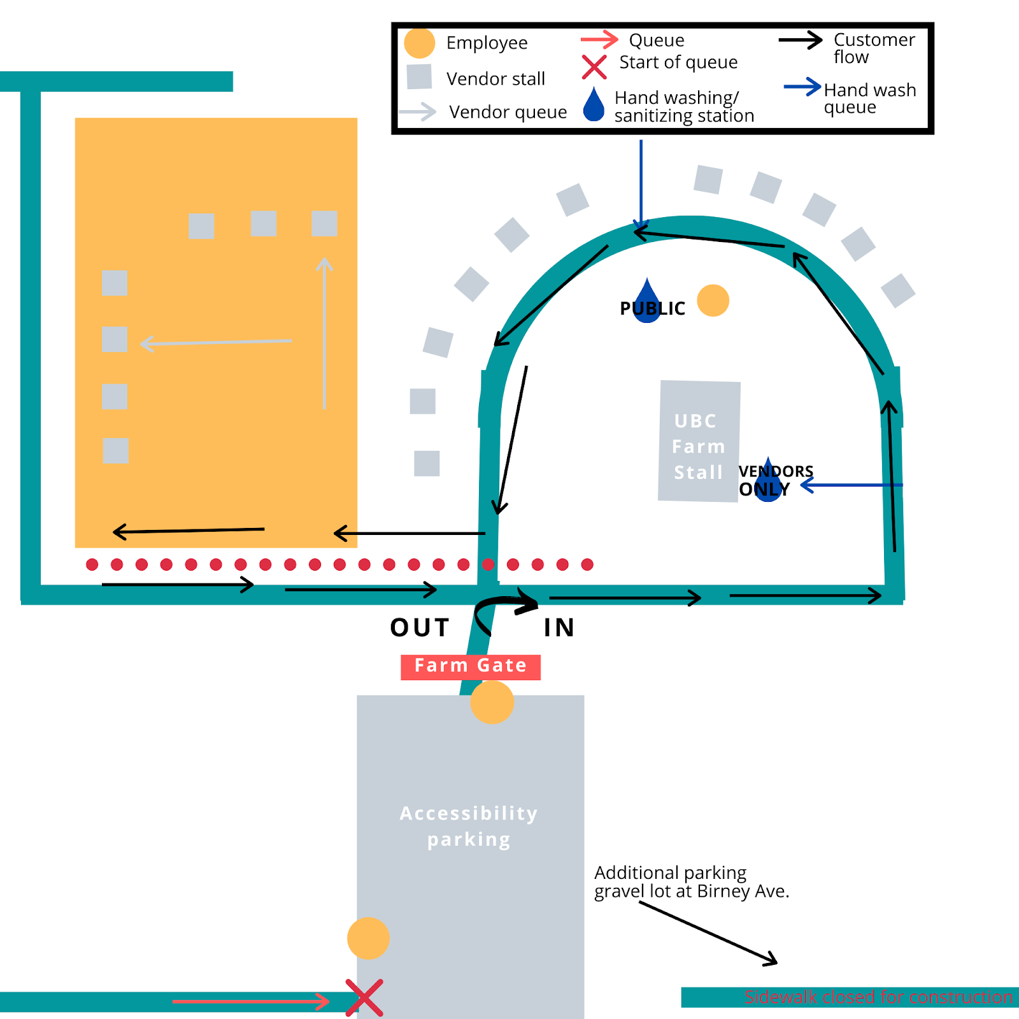

This is a tentative market map and this may change as we improve best practices throughout the season. We intend to maintain a one-way market, but the direction of flow and location of vendor stalls and queues may change moving forward.

Option II
Provided construction prevents customers from lining up on the sidewalk outside the UBC Farm.
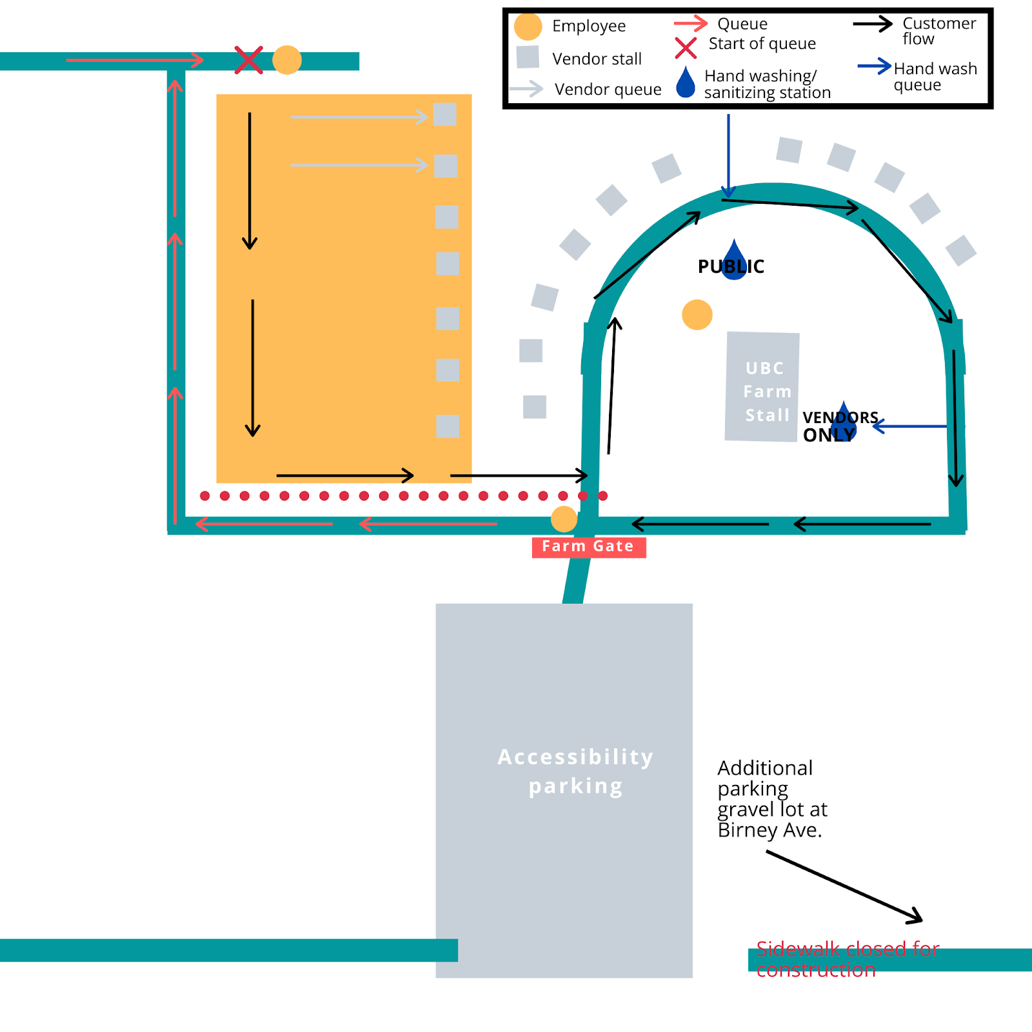We also hope to have an additional hand sanitizing station at the Farm gate, but we are uncertain that this will be possible given the high demand and limited supply of hand sanitizer at this time.

Appendix 4: U-Pick Plan
June 3, 2020 – v1 APPROVED June 4, 2020 by the CMT

*This plan has been developed to carry out a safe U-pick for berries at the UBC Farm, and is subject to change within the guidelines and safety protocol laid out by the BC CDC, the Provincial Public Health office and WorkSafe BC

UBC Farm COVID-19 U-Pick Safety Plan
This plan outlines how the UBC Farm will operate U-pick, in line with our Market plan (approved by the CMT on May 28, 2020) and our COVID-19 Farm Health and Safety Plan (originally approved by the CMT March 25, 2020; revisions submitted for further approval).

The UBC Farm is committed to continuing to provide fresh produce to the local community. COVID-19 restrictions, which have resulted in no volunteers and no practicum students being allowed on site, will limit the capacity of our field team to harvest the full yield of our berry crops. U-pick provides an essential service for the Farm: without members of the public engaging in U-pick, a significant amount of the berries could rot in the field this season. Thorough berry harvest is an essential part of pest and disease control and part of multi-year management plans for both strawberries and blueberries. In addition to the issue of food waste, a large quantity of unpicked and rotting berries in the field would have repercussions for the health of the plants in future seasons.

U-pick is an important revenue channel for the UBC Farm. In the 2019 season, U-pick accounted for $14,852 in sales ($6,185 strawberries; $8,666 blueberries).

On Saturday May 30,2020, Dr. Bonnie Henry in her daily press briefing specifically highlighted U-pick as a beneficial and approved activity which supports farmers during COVID 19, and also offers a safe outdoor activity for members of the public.

Overall requirements
U-pick typically occurs for four to five weeks of peak berry season, dependent on the weather and how quickly the berries ripen.

This year’s proposed start date for strawberry U-pick is June 9, 2020 and should run for two weeks; the proposed blueberry U-pick start date is likely the last week of June or first week of July.
- Customers need to be registered with the UBC Farm before they are allowed on site. Our CSA members will be given priority in the registration process.
- Initially, for our strawberry U-pick, there will be 10 slots per hour available; we will allow a maximum of two people from one household per slot. We will re-evaluate these numbers after the first U-pick to determine if they allow for adequate social distancing and if the number of slots, the timing of the slots, or the number of people allowed per household should be increased or decreased accordingly.
- Initially, U-pick will happen on Tuesdays and Wednesdays for a three hour window. We will re-evaluate what days and time slots are practical for our operation after the first week of U-pick.
- Registrants will consent to follow guidelines (as seen below) outlined for them before entry to The UBC Farm for U-pick. These guidelines will be communicated to them via email during the registration process as well as verbally when they arrive on site.

General Site Rules:
- Parking is located off site
- A UBC Farm staff member will meet customers at the gate, during allotted check-in times and provide them instructions
- Customers are required to wash or sanitize their hands upon entry and before picking berries.
- A handwashing station is available for customers to use before they start picking. We encourage customers to bring personal hand sanitizer with them as well.
- Customers are required to maintain physical distancing requirements in line with provincial guidelines. In order to maintain physical distance on site, we are limiting the number of people allowed on site for U-pick and requiring that customers pre-register for a time slot.
- We encourage customers to wear a protective face mask while on site if they are able.
- Customers should avoid touching their face, eyes, or mouth when U-picking. This means sampling berries is not permitted during U-Pick. We ask that if a customer touches their face they sanitize their hands before they continue picking.
- Berry containers will be provided for customers. Customers will not be allowed to pick into their own containers – they must pick into containers provided by UBC Farm.
- Customers are only allowed to pick within specified zones.
  - There will be a one way flow of traffic on the Farm and during U-pick.
- There will be a staff member near the field, to supervise the U-pick and process payments/weigh berries.
- When finished picking, customers will proceed to the allocated payment area for weighing and payment.
    - Staff who handle cash/card are not allowed to touch produce unless they wash their hands first
    - Staff will wear a mask and gloves
- Customers will be denied entry onto the Farm site if exhibiting symptoms of illness (fever, vomiting, diarrhea, coughing, fatigue, body aches) or if they have been in close contact with someone with symptoms. This will be communicated to customers via email during the registration process.
- Customers are not allowed entry into any of the buildings on site.
- A portable toilet by the Harvest Hut is available for customer use.
- No recreational use of the site will be permitted.
- No pets allowed on site.
- Maximum two people per party. Both must be engaged in the activity of picking, and pick beside or across from each other.
- Children under the age of 12 must be accompanied by an adult at all times, must be engaged in the activity of picking, and must be able to abide by site rules.

Appendix 1: Sample communication for customers/participants – to be shared by email as well as in printed form at the Farm gate.

UBC FARM U-PICK INSTRUCTIONS

We’re happy to be able to offer u-pick this year! Thank you for coming, supporting the UBC Farm, and following the U-pick procedures

- Please wash or sanitize your hands upon entering the UBC Farm at the designated hand washing station. If possible, please wear a protective face mask while on site at the Farm.
- You will be designated a row in the field to pick from. Please stay within your row.
- We ask that you pick and pay within your registered time slot. Please proceed to payment before the end of your registered time to allow the next round of participants to begin picking.
- Maximum of two people per household permitted. People in the same party should pick directly beside or across from one another.
- We know this is a hard one, but NO SAMPLING of berries during U-pick
- Avoid touching your face while picking. If you do, we ask that you sanitize your hands before you resume picking. We recommend bringing your own hand sanitizer for this purpose.
- Use only the berry containers provided by the UBC Farm. You cannot use your own containers. Containers will be provided after you wash your hands.
- Once you have finished picking in your designated row, please proceed to the payment station set up beside the berry patch.
- Access to other parts of the UBC Farm is still closed at this time. Please exit the Farm once you have finished picking berries and paying for them.
- We recommend washing your fruit before consumption.
- At all times, please follow directions from UBC Farm staff. They are there to support you and ensure you have a safe U-pick experience.
- Enjoy your berries!
Thank you for your patience and support!

The map below indicates the path that you should follow to the type of berry u-pick you have registered for. Please do not stray down other pathways on the Farm.
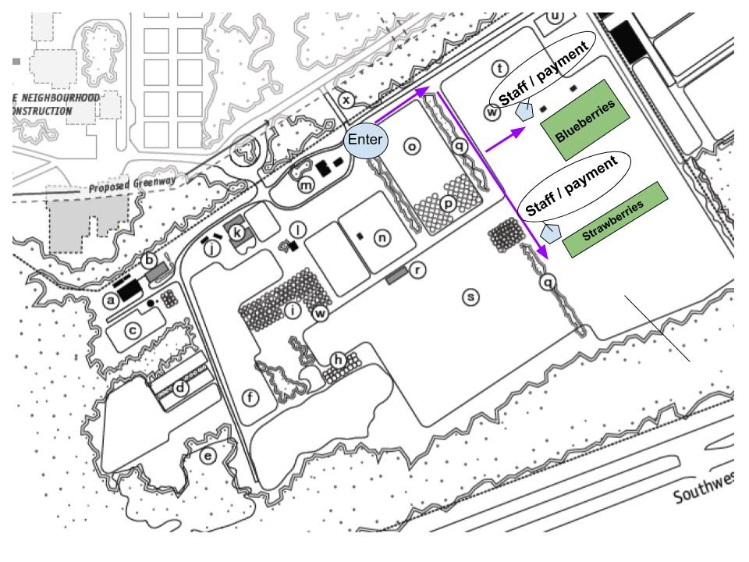
Appendix 2: U-Pick Internal Planning Notes

Specific Distances in Strawberries:
4 rows total. 384 ft row length. 3.67 ft between rows.

5 parties per row. 2 rows picked at a time. 10 parties in field in total

5 parties per row means people have 75 ft of distance without reaching another party in the row.

Picking alternating rows from one side only on alternating days (e.g. rows 1 and 3 on Tuesday; rows 2 and 4 on Wednesday) means people have a minimum 7.33 ft between the pathway they are in and the pathway another picker is in.

Strawberry U-pick will be held twice weekly and should run from June 9 to June 30, harvest dependent.

Specific Distances in Blueberries:
17 rows total. 120 ft per row. 10 ft between rows.

2 parties per row. 4 rows picked at a time. 8 parties in the field in total.

2 parties per row means people have 60 ft of distance to pick without reaching another party in row.

Picking alternating rows on alternating weeks: Tuesdays can pick rows 1, 3, 5, 7; Wednesdays rows 2, 4, 6, 8 one week, then following Tuesday 9, 11, 13, 15, Wednesday 10, 12, 14, 16 to give each row one week to recover from U-pick.
With alternating rows, the minimum distance between one row of pickers and another is approximately 10 ft (since picking will occur on both sides of each row).

A maximum of two parties will be allowed per row at one time to ensure proper physical distancing and eliminating the need for parties to pass by each other in one row. A maximum of 8 parties total will be allowed per time slot.

Blueberry U-pick will be held twice weekly and should run from late June to mid-July, harvest dependent.

Appendix 5: Previous Plan (approved March 26)
Approved March 26, 2020 by the UBC Crisis Management Team

The UBC Farm is committed to providing safe, healthy produce for the local community. In order to do this, we are creating and implementing on-site protocols to ensure we can safely work on site together. This document is a working plan for on-site staff safety. This working plan is adaptable and will be updated following UBC and Government of British Columbia recommendations as needed throughout the procession of the growing season.

General Procedure:
We have scheduled weekly meetings to review and update UBC Farm COVID-19 Procedure
Meetings organized by: Marika Dunham, Sales Manager
- At our weekly virtual meeting we will discuss how the practices and policies outlined in this document can be improved to ensure workers safety on site.

Our general procedure at the Farm involves:
- Limiting access to the site only to employees deemed essential for farm production, the site has been closed to members of the public as of March 19th, 2020 and will be closed until further notice.
- Staff will assess their own health before coming to work each morning. Potential symptoms of COVID-19 will require them to stay at home for a self-isolation or monitoring period of 14-days (as appropriate and based on provincial guidelines) before returning to work
- Staff are required to review and adhere to UBC and Government of British Columbia policies on self-isolation in the event of illness, or contact with individuals who are ill
- Staff that become ill while at work will self-isolate until they are able to seek care or return home, as appropriate and based on provincial guidelines. Any area where staff members have self-isolated on site due to illness will be disinfected.
- Maintaining social distance of two metres within buildings and on site (outside on farm grounds)
- With the reduced staff onsite, if any workers have to work in isolation for extended periods (more than two hours) they must follow safety procedures including having their two-way radios on their person; checking in regularly with their supervisor; indicate to their supervisor when they are no longer working in isolation by using radio or cell-phone text.
- Sanitizing high touch items (e.g. phone) upon arrival on site
- Identify and limit shared equipment and other collective points of contact, and providing staff members with designated tools that are not shared
- Implementing a cleaning and sanitizing procedure for any shared equipment with a clearly designated individual in charge of each task/station
- Practice adaptive management based on evolving information and situations
- Meeting by phone, Zoom, or other remote means
- Staggering office time and having designated work stations
- Increasing signage and locations where people can disinfect (their hands, equipment, and produce)
- Maintaining sanitizer spray bottles in all shared areas

Emergency Procedures:
- Maintain and adhere to Building Emergency Response Plan (BERP) (in place and updated March 25, 2020)
- Maintain and communicate clear muster point on the Farm site, which is located by the Main Gate and indicated with signage.
- Call emergency response in case of urgent medical or safety situations:

Emergency and Essential Phone Numbers

Fire Police  Ambulance | 911
Occupational First Aid  (Vancouver Campus) | 604-822-4444
Hazardous Material Response  (Vancouver Fire & Rescue Services) | 911
UBC Hospital Urgent Care  (8:00 a.m. – 10:00 p.m.) | 604-822-7662
Poison Control Centre | 604-682-5050
Campus Security  (For an Emergency call 911) | 604-822-2222

What information is required when I dial 911?

∙ Describe the Emergency
∙ Location
∙ Building Name
∙ Building Address & Room #
∙ Phone Number
∙ Do NOT hang up as additional information may be needed
***

Transport to Site:
- Staff will arrange to commute to work via bicycle, personal vehicle (one person per car), or other low risk transport.

Front Gate:
- Disinfect lock and chain daily (delegated to person on designated lock up)
- Remain closed to the public throughout the day.

Farm Centre:
Farm Centre Manager: Tim Carter, Field Manager
- A weekly designated staff member will be in charge of disinfecting all surfaces of shared spaces at the end of each day.
- If custodial staff are no longer able to attend to the site, this staff member will review cleaning procedures with Infection Prevention & Control, additionally mop floors and clean bathrooms. The staff member will wear gloves.
- Use of locker area will be discontinued. Staff will each have a new designated place for their belongings, a minimum of two metres apart.
- All staff who need access will be assigned a computer workstation for their sole use.
- No more than two people can be in the Farm Building Office at one time. These two people will have designated computer stations at either end of the office, always maintaining a minimum of two metres apart.
- Further staff will be assigned computers in separate spaces: Field Office (2), Children’s Programming Area (1), Classroom (1), Harvest Hut (1). Staff may also bring personal laptops to work in the Marquee (2) or Children’s Greenhouse (2).
- Only one person will be allowed kitchen access at a time, with a staggered lunch rotation, this person will be required to sanitize all surfaces at the end of their lunch break.
- No shared food or beverages.
- Rain gear hung in hallway will contain only active staff wear, and will be spaced a minimum of two metres apart.

Harvest Hut:
Harvest Hut Manager: Marika Dunham, Sales Manager
Current SOP health and safety plans will be updated with the following:
- Surfaces and tools will be sanitized on a regular schedule
  - These procedures and schedules will be updated as needed according to BC health authority guidelines
- Produce totes and crates will only be handled by those wearing disposable gloves to limit contact and will be sanitized daily after use.
- No more than two people will be in the harvest hut at one time. They will maintain a distance of two metres.
- All outdoor processing stations are set up at least two metres apart. No more than 1 worker will be at each station.
- Access to the Harvest Hut computer will be restricted to Marika Dunham.
- Shared rain gear + gloves will be removed from harvest hut (labeled personal rain gear + gloves to be used exclusively)

Tool Shed & Tool Use:
Tool shed manager: Evan Goh, field technician
- Workers will disinfect every tool before returning to tool shed (Bleach bottle and paper towels to be stored outside shed)
- Assign commonly used tools (eg. articulated hoe) to individual field workers
- Daily disinfecting of high traffic areas (eg. door knobs, work bench, irrigation toolboxes)

Greenhouses:
Seedling Greenhouse Manager: Mel Sylvestre
- We have a designated Seedling Greenhouse Manager who will be solely allowed entry to the seedling greenhouse, responsible for all seedling watering and care.

Outdoor fields:
Fields Managed by pre-existing Field Managers: Goosefoots: Hannah Lewis
Brassicas/Hoophouses: Alisha M’Lot
Alliums/Legumes/Field Cucurbits/Potatoes: Alex Pomeroy Perennials: Melanie Sylvestre/Evan Goh
- Workers will assure two-metre distance while working in fields.
- Only two workers will be allowed to work in field hoop houses and tunnels at the time and will be working at a minimum of two metres apart.
- Irrigation systems will be turned on and off only by the leader of that field.

Machinery and Equipment:
Machinery & Equipment Manager: Tim Carter, Field Manager
Blue Whale Van:
- One person in vehicle at a time
- Disinfect steering wheel, seat, gearstick, door handles after use.
Tractors:
- Disinfect steering wheel, gear sticks, seat, seat adjustment, three-point hitch safety knob, implement pins and tools in toolbox after use
- Each staff allowed to drive a tractor will have their own ear protection labelled for their own use
Small engine:
- Designate specific staff for each piece of equipment, PPE assigned to specific people (hardhats, eye protection, hearing protection, gloves)
- Full disinfect of touched surfaces after use
Harvest Carts:
- Carts assigned to one per person per day. Disinfect carts after use
Walkie Talkies:
- Walkies are already personally assigned + labelled. Staff will keep them on their person, not put them down on commonly used surfaces, and disinfect regularly.

Handwashing Stations:
Handwashing Station Manager: Mel Sylvestre, Perennials and Seed Coordinator
- Handwashing stations with hot water will be stocked with soap. Handwashing stations without hot water will be stocked with hand sanitizer.
- Disposable Nitrile gloves will be available at each station.
- Supply will be checked daily

Field Inputs and Amendments:
Input & Amendment Manager: Alisha M’Lot
- Disposable gloves will be available at each field input storage location and will be used for each application. This includes backpack sprayers and other application tools.

Tote washing:
Tote Safety Manager: Kyne Tsai
Tote sanitization procedures will be in place for delivery containers
- Designated washing gloves mandatory for all washing steps
- 2m apart for soaping and hosing down totes, sanitize if people need to switch
- Discontinue use of shared waterproof aprons
- Sanitize all wash surfaces, tools, and gloves when done

Harvesting and Processing:
Manager: Marika Dunham
- Harvest procedure in-field will be managed by specific field managers.
- All food will be handled only while wearing disposable gloves.
- All equipment that will come in contact with food will be sterilized before usage (totes, knives)

Sales:
Sales Manager: Marika Dunham
Our current sales plan is to expand our CSA offerings (open more available CSA shares) which
will be paid for online and then arrange for staggered pickup outside the Farm gate, and
following all BC regulations on spacing and hygiene (e.g. only one customer will be scheduled
for pick-up at a given time). We are also examining our capability to provide CSA delivery, either
by UBC Farm staff or with partner organizations. We will also continue our wholesales to SHHS
and are pursuing other outlets, including local grocery stores and local food delivery services.
While markets are still currently allowed under BC Provincial Guidelines, and are considered an essential business that can remain open in the Provinces of Ontario and Quebec, we will be discontinuing our markets until further notice. Markets typically start in June, and we will request a review of our sales plan at that time from UBC.

Alongside sales, food donations can be arranged, such as the regular donations already made to Quest Food Exchange.

CSA:
CSA Manager: Kyne Tsai
- We are considering expanding our CSA program to enable us to provide more of our community members with food access in this greater time of need. CSA allows for less interaction with the public, and fewer points of contact with handling consumer produce.
- Exploring alternate share sizes and delivery/pick-up methods to as many customers as required, such methods may include switching to individual cardboard boxes to distribute weekly shares.
- Community events (e.g. annual start-of-season orientation potluck) for CSA members are cancelled until further notice.
- Collaborating with other farms in the area to establish a support system and potentially organizing delivery as a method to drop off shares to limit in-person contact
- Monitoring possible pick-up procedures to limit crowding issues
- Handling produce during the harvesting and processing will only be done wearing disposable gloves. Because we are currently in the off season, and just starting our planting and supply ordering, our stock of gloves consists of two boxes of 50, with another 16 boxes ordered. We anticipate we may need another 75-100 boxes of gloves to continue the practice of harvesting with gloves throughout the season.

Markets:
Markets Manager: Carissa Kirk
While markets are still currently allowed under BC Provincial Guidelines, and are considered an essential business that can remain open in the Provinces of Ontario and Quebec, we will be discontinuing our markets until further notice. Markets typically start in June, and we will request a review of our sales plan at that time from UBC.

We believe that our markets provide an essential service for the community: they act as critical food access points for local residents to purchase food while ensuring local farmer livelihoods and reducing food and crop losses. They are crucial to food security and healthy buying habits. COVID-19 Adapted Farmers Markets additionally have the ability to prevent consumers from handling any food, helping to limit spread of the virus. We are currently reviewing our market planning to ensure that our markets can remain a safe place to access food. We are closely monitoring provincial guidelines and the response of the Vancouver Farmers Market and BC Association of Farmers’ Markets to provide COVID-19 Market Safe Procedures. Contingency plans include delaying the start of the market and seeking alternative methods of distribution, in collaboration with other market vendors.

Essential changes that can be made to any in-person markets (Stage 1-3):
Stage 1. Hosting our Multi-Vendor Market with only sales of food-primary vendors allowed with priority on basic foods
- General Changes to make:
  - “Shop, don’t stop” will be the theme of the year. This means that we will not have music, or activities and will be encouraging customers to shop for what they need and leave.
  - More handwashing and sanitation stations will be available at the Market
  - Vendors will be more spread out, to allow greater physical distancing
  - Sampling products will not be permitted
  - Pylons will be put out to make starting points for queues at each stall
  - We will ask customers to maintain a distance of two metres from the customer before them in any queue
  - Vendors will only be able to serve one customer at a time
  - Only vendors will be allowed to touch their product, in order to package it for the customer
  - Payment machines will have to be regularly sanitized, preferably between each customer
  - Vendors will be required to have hand sanitizer, disposable gloves and sanitizing spray to ensure all surfaces are as safe as possible
  - Food products will need to be protected from sources of contamination at all times during storage and display
  - Communications materials such as magazines and stickers will not be available
  - There will be no seating areas available at the market, as this encourages close gatherings
  - Anyone with any symptoms of illness will be asked to leave the market– both customers and vendors
  - Reusable bags, cups, etc. will not be encouraged at our market this year
- Additional changes to consider:
  - Limiting vendor numbers
  - Vendors will be prioritized to vendors in our area.
  - Mandating card payment to eliminate any handling of cash – this would require a payment system such as square
  - Paying your fees using our online system, rather than with cash at the end of the market day
  - Having one staff member at your stall dedicated to payments to prevent the need to handle payments and products
  - All food vendors may be required to have their own hand washing station at their stall
  - Online platforms being utilized to allow for orders and deliveries
  - No dogs or animals at the market
  - Only food producers utilizing a commercial kitchen will be permitted to sell OR those who do not utilize a commercial kitchen will have to disclose this information
  - Limiting the number of people allowed to shop at one time
  - Requiring further personal protection equipment
Stage 2. Hosting a market for only UBC Farm Produce
- General Changes to make:
  - Refer to 1. A, for the same protocol
- Additional changes to consider:
  - Refer to 1. B, for same protocol, as well as:
  - Mandating card payment to eliminate any handling of cash
  - Online platforms being utilized to allow for orders and deliveries

Stage 3. No in-person markets; online & CSA only
- Using cardboard boxes to package food for pickup
- Consideration of whether pickup occurs on Farm site or at gate
- Ensure pickup time windows and physical barriers to regulate social distancing of customers

SALES DATA
- Total number of shoppers at the market throughout the season: approximately 15,924 in 2019 15-20% being students, total sales=$416,000
- 46% of our shoppers are regulars, attending 5 or more markets within the season. This demonstrates that the market is an essential supplier of weekly groceries for the UBC & Wesbrook community.
- 55% of shoppers in 2019 were visiting the market more than in 2018.
- Amount of coupons redeemed at 2019 market: $3664, which demonstrates our impact on food accessibility and equity. People are provided coupons through the AMS Food Drive, and other locations to target those in need.
- External vendors (Not UBC Farm) sold $233,869.45 worth of product at the 2019 market.
- The UBC Farm had an average of 315 transactions per market, generating $133,221.77 in revenue in 2019.
- Numbers for Donations: In 2019, the Farm provided $8,592.00 worth of food to charitable food donations.

***
I confirm that this Safety Plan has been shared with staff both through email and will be made available as a shared document. Staff will provide email confirmation that they have received and read the document.

Date: March 25, 2020

Name: Clare Cullen

Role: Operations Director

